**ABYSS**

**TRACKING ACTIVITY AND PROJECT MANAGAMENT**

**SYSTEMS ANALYSIS & DETAILED DESIGN**

**SSYADD SS201**

**BSCS-SS201**

**Mr. Jayvee Cabardo**

Client

**Mr. Jose Eugenio Quesada**

Subject Professor

**SY 2022-2023**

**Group Members**

Leader

**Noreen Keziah Sioco**

Members

**Bea Angeline Cruz**

**Mark Gerald Giba**

**Joseph Adrian Lebag**

**Jose Norberto Verde**

**DESIGN THINKING STAGE 1: 5 WHYS**

**5 WHYS**

1. **Why do you need this kind of project?**

**Client Response**

There’s no way for me to monitor progress that is in progress. And it’s one of my main responsibilities as program director to monitor ongoing projects.

**Faculty Response**

We can’t keep track of the projects being developed because we don’t have the status. We need to ask Sir Jayvee of the status and what has been done and that’s only through email. And sometimes emails are being flooded that cause the pile of the works. And because of that we are not reminded by the projects that is needed the attention.

**Student Response**

This project will help the process of getting updates, information, and accessing files more optimized and time efficient. Plus, it can also be a collaborative environment for every person that is involved in the project creation.

1. **Why did this problem occur?**

**Client Response**

Of course, we don’t have a tool to monitor an overwhelming number of projects. It’s a good problem because more projects mean more ingredients for your partners, but it becomes overwhelming to monitor.

**Faculty Response**

We are reminded that there should be a tool to track the projects. When the stakeholders give us updates and if they ask for updates, they ask Sir Jayvee. And if they get Sir Jayvee as the proponent of the project, they need to ask the APC side. Those involve in the project but every term there are times that there are changes in the faculty. And when that happens, we are no longer to keep track of the project history project.

**Student Response**

This problem occurs when the client or the project manager needs a report and update on the project, but they struggle to provide some because of cluttered files and Info’s.

1. **Why were you struggling to solve the problem?**

**Client Response**

Because there’s no standard tool to use. If there’s a tool to monitor it would be easier. And there’s no tool not only for me but for everyone as well.

**Faculty Response**

The struggle is when you must search for a keyword. The information is not one click away. For example, I want to keep track let’s say in Microsoft teams. I want to keep track of students who has not submitted their assignments, so I just go to the grade stats. I get to see if they opened the assignment, if they already turned in, and if I already graded them or not.

**Student Response**

There is no available tool to monitor each project.

1. **Why do you think projects like this are necessary?**

**Client Response**

To streamline the process so I look up other areas of the project easily.

**Faculty Response**

To easily track the progress of projects and our commitment in our stakeholders. If it’s already fulfilled or not. Which projects are shelled, which projects are for deployment, and which projects are for publication. For the faculties members involved to know the status of the project.

**Student Response**

The project is necessary because it can be helpful in monitoring and sending project updates to the persons involved.

1. **Why would it be different if the office had this application for use?**

**Client Response**

I would never know but based on the identified problem and objectives of the project. It would ease the overwhelming tasks that needed to be monitored.

**Faculty Response**

Easy tracking and monitoring.

**Student Response**

That is yet to be determined but, this application is expected to help lessen the hassle and ease the overwhelming tasks that need to be done.

**Customers Personas**

**Client’s Personas**

**Motivations**

* I get paid to do my Job and my loyalty to the company.

**Frustrations**

* I guess time management.

**Influences**

* Leaders in the company like colleagues, supervisors, and presidents.

**Personality**

* I’m more of a leader at work. I like giving instructions to my team.

**Faculty’s Personas**

**Motivations**

* Salary, I need to earn that’s the first one.

**Frustrations**

* The students not submitting on time.

**Inspirations**

* The students, I want to let my students give the knowledge that I want to inspire them.

**Personality**

* Precise, because as computer science we have to have basis. So, we don’t just put out or write something or declare something that is not based on evidence or facts.

**Student’s Personas**

**Motivations**

* Good grades and Family

**Frustrations**

* Lack of time management

**Influences**

* Parents, teachers, and friends.

**Personality**

* Positives, confident, and caring.

**Say and Do**

* The job and flow of work done in the office is somewhat a process of how projects are being completed yet the customer needs to improve the workflow or process of completing projects and simplify things**.**

**Empathy Map**

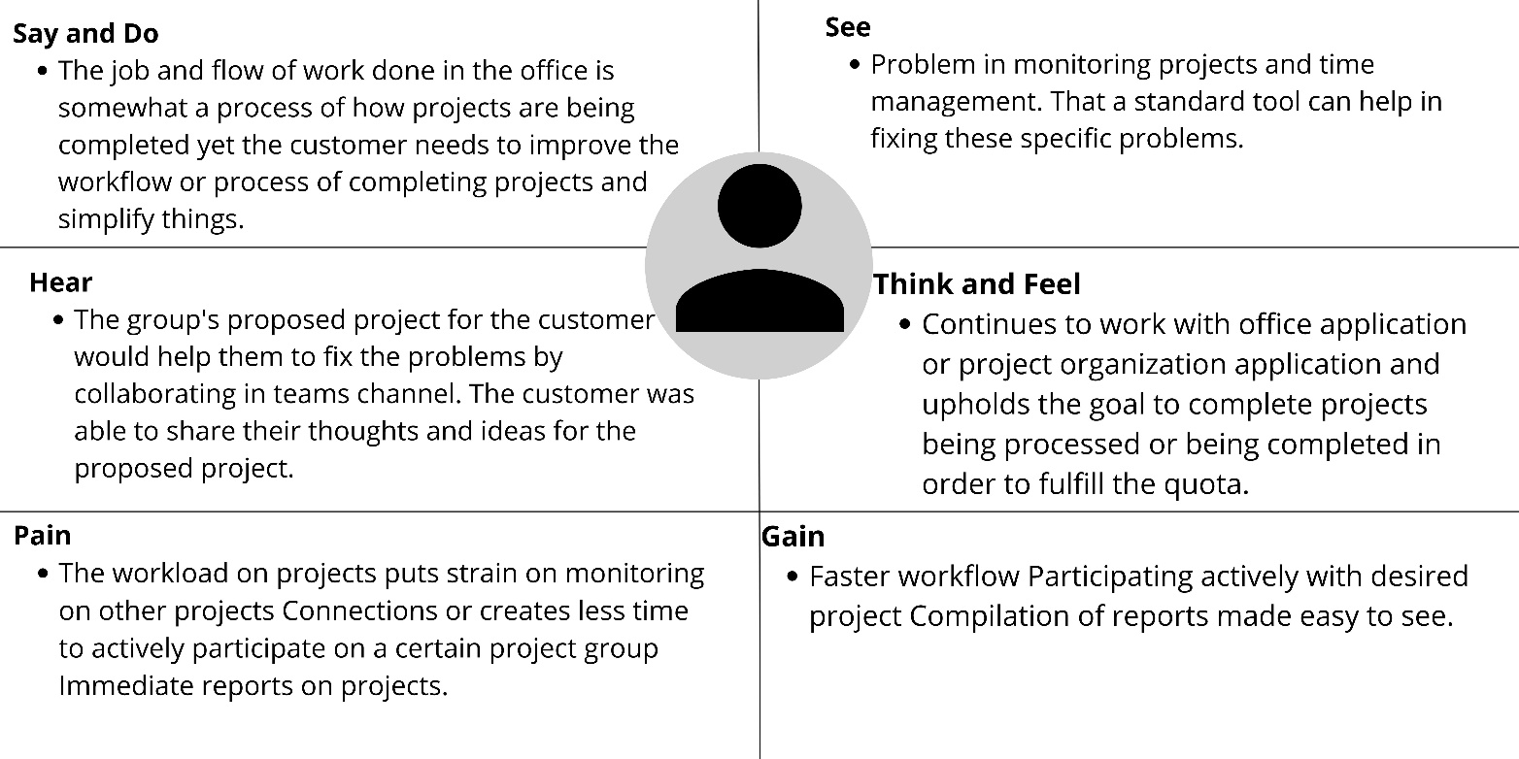

**Customers Jobs**

* Project Director of Asia Pacific College
* Faculty of Asia Pacific College
* Student at Asia Pacific College

**Client’s Pains and Gains List**

**Pains List**

* Time management
* Having a hard time monitoring project.
* Needs a standard tool for work.

**Gains**

* With the help of the proposed project our customer will be able to get things done on time.
* The project proposed will help the customer with their problem in time management.
* It will also help them to collaborate more with their colleagues and save time in their work.

**Faculty’s Pains and Gains List**

**Pains List**

* Can’t keep track of the projects.
* Having a hard time in searching for projects in emails because it was piling up.
* Changes in faculty caused them to have a hard time track and search for the projects in progress.

**Gains List**

* With the help of our proposed project, the faculty will have an easier time in searching for projects because of our programmed bots in the application.
* The project proposed can help the faculty to organize their progress from planning, in progress, and projects done.
* It will also help them to save time in doing their projects.

**Student’s Pains and Gains List**

**Pains List**

* Needs a standard tool to organize homework that needed to be done.
* Time management.
* Team collaborations are hard because or the unorganized meetings or no notifications received for scheduled meetings.

**Gains List**

* With the applications feature it will help the student to monitor their homework.
* Team collaboration will be easier because the application can organize the meetings schedule.
* Can save times and pass their tasks on time.

**DESIGN THINKING STAGE 2: DEFINE**

**Clustering Problem Areas**

Many ideas were stemmed through the meetings we’ve had with the customer’s and tackling on the problem that faculty is facing, with constant questions and revisions we’ve tackled the specific problems the customer has:

**Problems Statements from Customer’s Jobs**

|  |  |  |
| --- | --- | --- |
| Client’s Problem | Faculty’s Problem | Student’s Problem |
| * Client’s time management is disordered * Client have a hard time monitoring all projects * Client wants a standard tool to use for work | * Faculty’s member could not track projects * Faculty have a hard time looking for projects through email due to projects piling up * Faculty changes can give them a hard time to track and search projects in progress | * Student’s time management is in disarray * Student needs a standard tool organize and finish homework * Student could not coordinate properly due to unorganized meetings and not being notified for scheduled meetings |
| Customer with similar Problems | | |
| * Client and Faculty have the similar problem which was monitoring and tracking problems due to projects pilling up * Client and student has difficulty organizing their time or schedule, and want a standard tool to work and coordinate with each other including the faculty * Faculty and client have a hard time with tracking and searching projects changes made in the office through email | | |

After further discussions about the problem points, we would have to align this with a proposed solution on how we can align this with the said problem statements

**How/Might/We imagine Questions**

1. **How might we reimagine a more efficient means to track and document the APC student projects?**

*Having a system wherein the faculty or office have a means to document the process of each projects in one platform*

1. **How might we reimagine a more helpful way to find out project information/details immediately?**

*Giving the client a way of having a systematic way of approach in visualizing information on the spot and notifying directly the changes that are made.*

1. **How might we reimagine a more systematic way of getting updates and reports from APC student projects?**

*By having a systematic way of approach in visualizing information on the spot and notifying directly the changes that are made.*

1. **How might we reimagine a more effective way to share documents, videos, PowerPoint, and files between the office and students group?**

*A helpful way for both group to share information easily is to have a platform where in the designated or assigned group is allowed to share sensitive information only available to them.*

1. **How might we reimagine a way for both client and project group to communicate and cooperate?**

*It can be helpful to have a platform for both the client and all the project group he is handling which can ease communication directly to the client.*

**DESIGN THINKING STAGE 3: IDEATE**

1. How might we reimagine a more efficient means to track and document the APC student projects?

* A standard tool that has the functions and extra features that would fill the client, faculty, and student needs in tracking and monitoring projects. By having a standard tool, they can take information about the project more effective and easier way.

* A progress data tracker with the numeric of 0-100 and a task board. the progress tracker will show the users how much progress have they done in doing their projects. With the help of the task board, the user will have a guide on the things that they need to be done in their project in progress.

1. How might we reimagine a more helpful way to find out project information/details immediately?

* Bots that would give the target market the notification feature. With the help of bots programmed, it will be easier for the users to notice and immediately work on the projects that needed to be done first.

* A more effective way to also get information immediately is for the assigned member of the project to make their work done collaborative. By that, other members of the project will be able to list down the important details of the project in progress.

1. How might we reimagine a more systematic way of getting updates and reports from APC student projects?

* Putting a notification function to inform the client of the project about the revisions and the latest updates.
* Adding a page only accessible for the client with the help of a report bot that each member of the group can directly send data to the client.

1. How might we reimagine a more effective way to share documents, videos, PowerPoint, and files between the office and students’ group?

* Make a collaborative environment that has the functions to connect, share, and post to one user to another. The users will be able to post their works I the system that can be seen by the members of the group as well as the office or the client, where they can comment in it to let the others make amends on the project in progress.

1. How might we reimagine a way for both client and project group to communicate and cooperate?

* A simple chat box where the client can directly communicate the project group.

**DESIGN THINKING STAGE 4: PROTOTYPE**

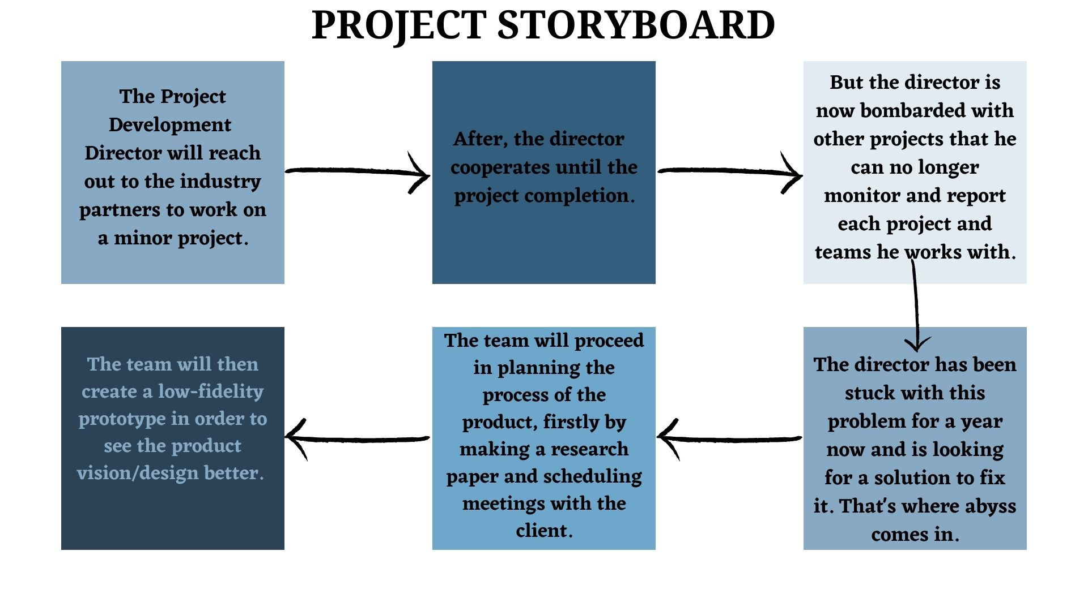**CLIENT STORY BOARD**

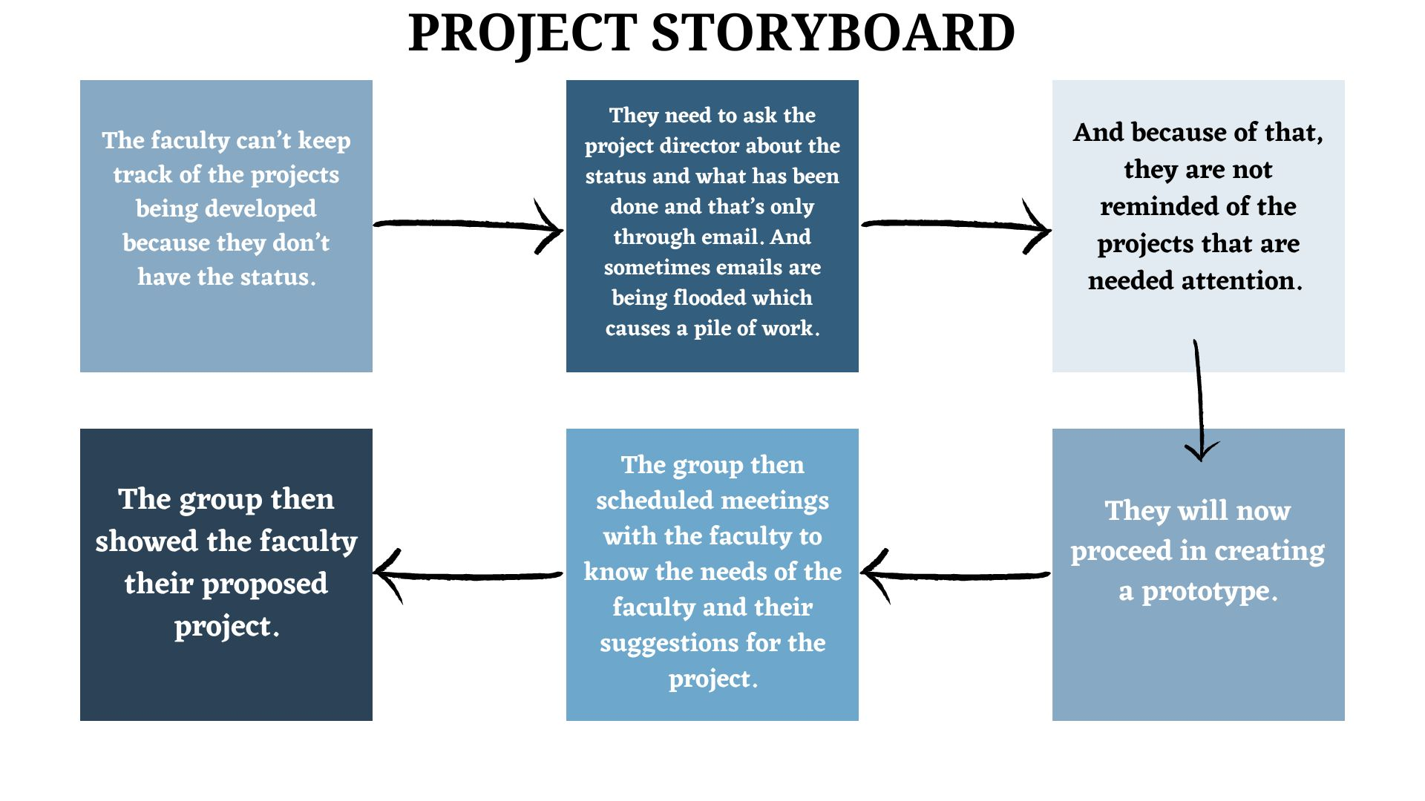**FACULTY STORY BOARD**

**STUDENT STORY BOARD**

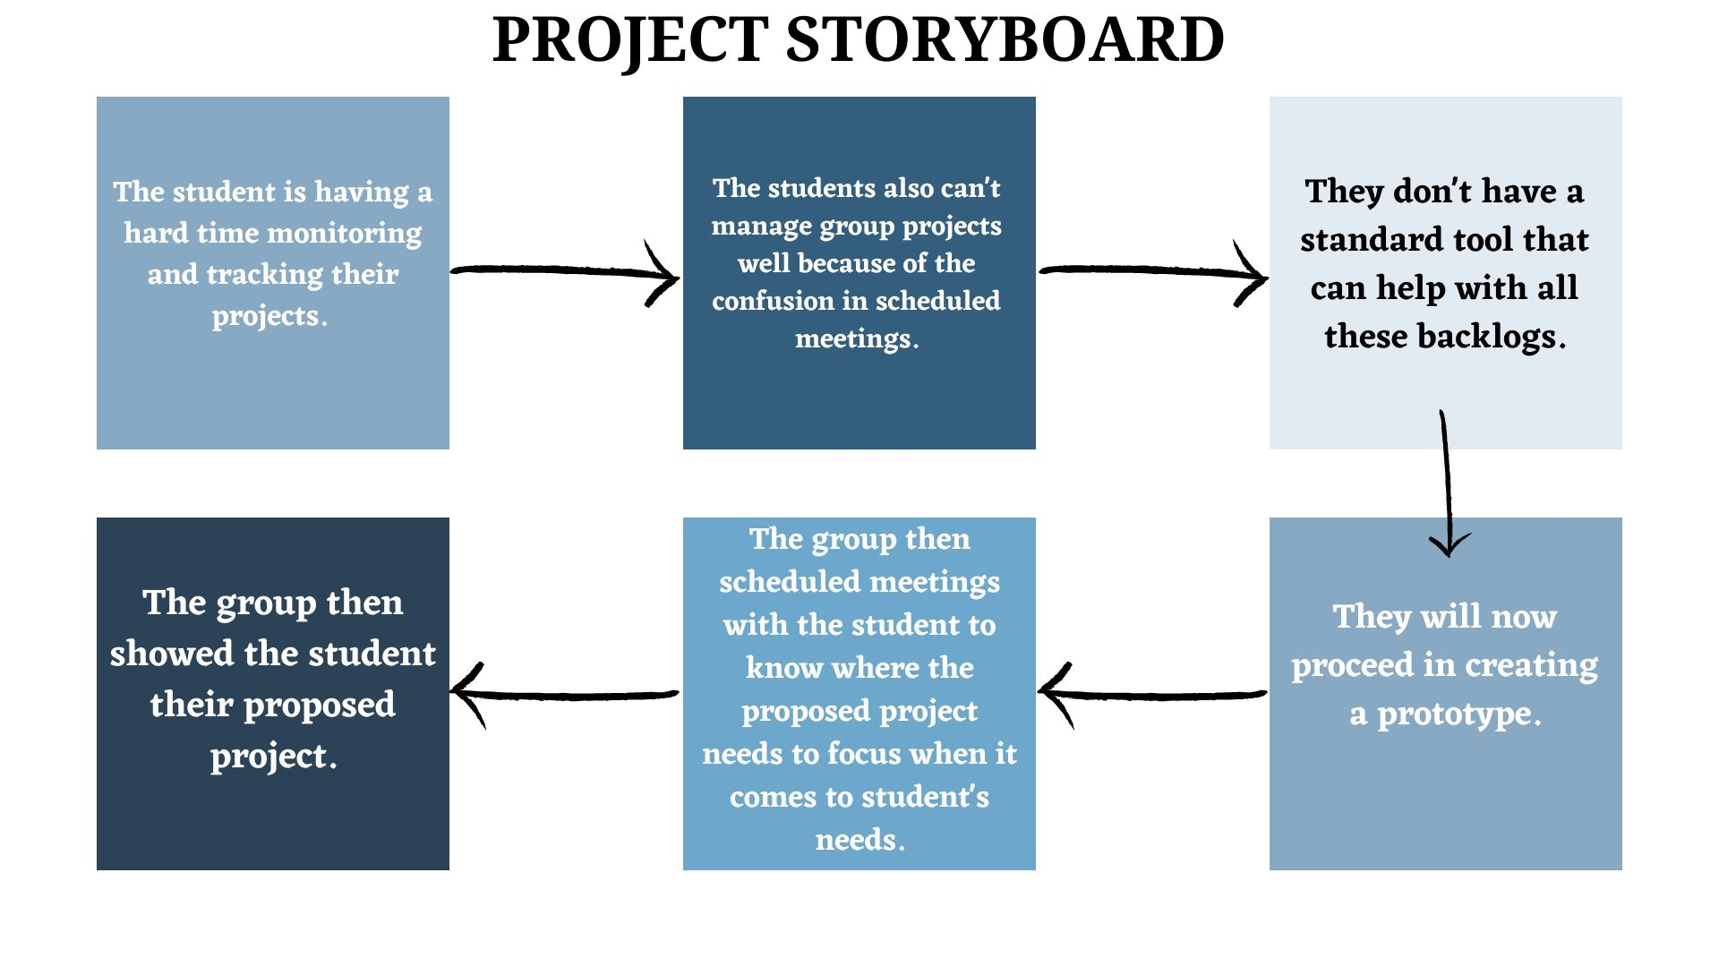

**MOBILE WIREFRAMES FOR STUDENTS**

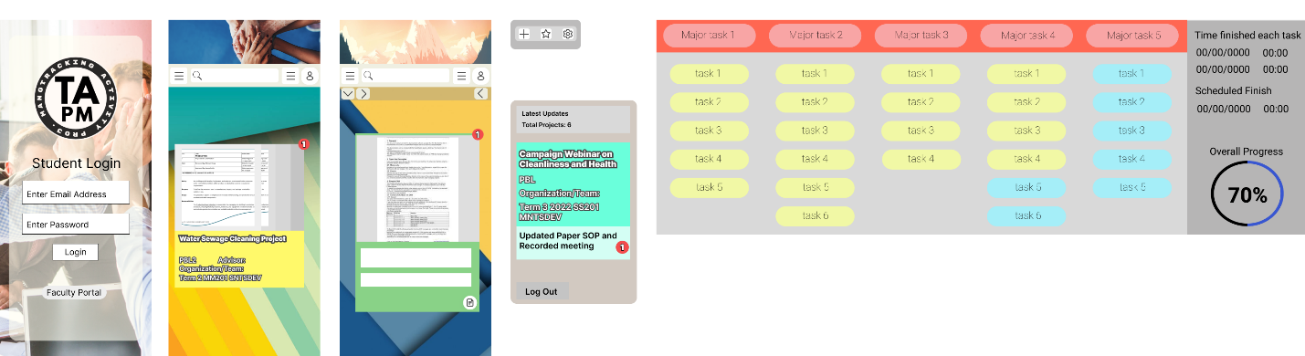

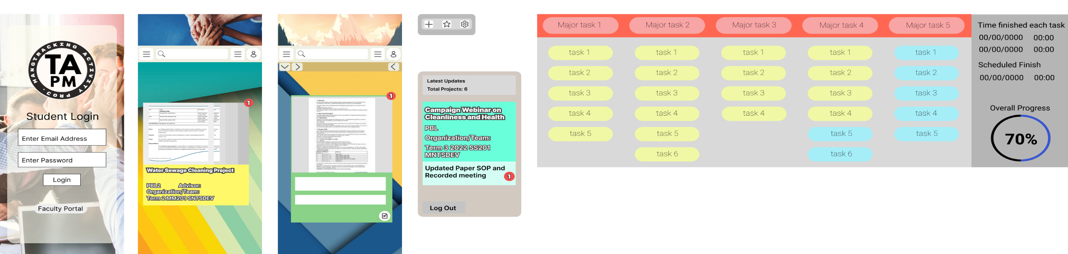

HOME PAGE

STUDENT LOG

IN PAGE



TASK BOARD WITH DATA NUMERIC TRACKER

FOR PROJECT UPDATES

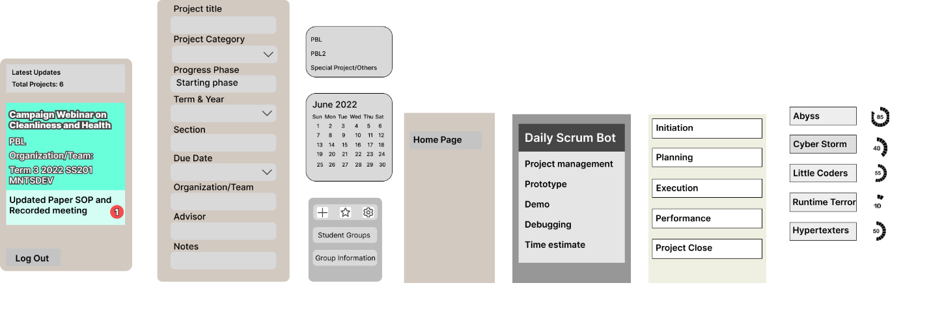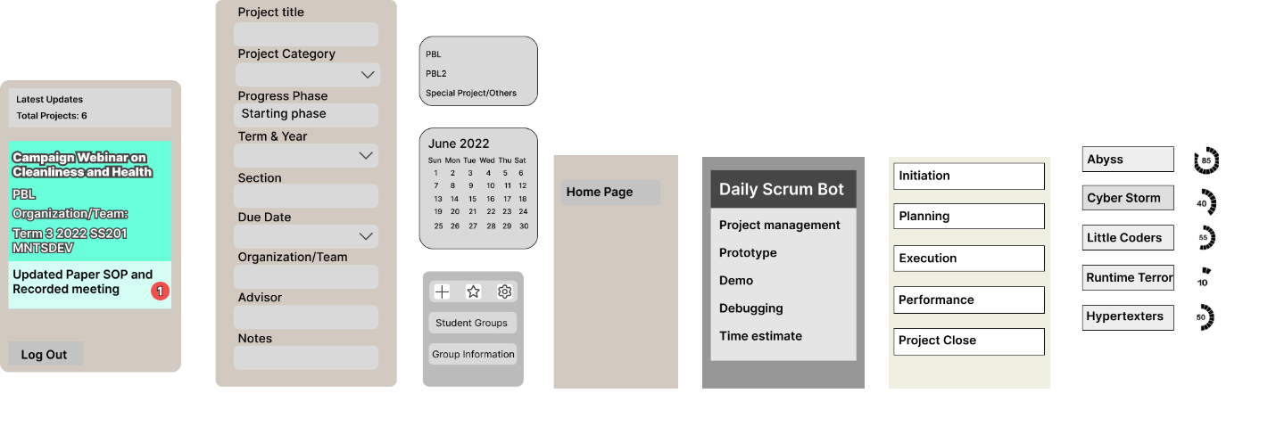

DAILY SCRUM BOT

PROJECT’S MONITORING GUIDE

ADDING PROJECTS

**MOBILE WIREFRAMES FOR CLIENT AND FACULTY**



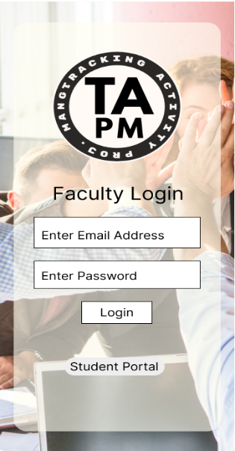

CLIENT/FACULTY LOG

IN PAGE

HOME PAGE



TASK BOARD WITH DATA NUMERIC TRACKER

FOR PROJECT UPDATES





DAILY SCRUM BOT

PROJECT’S MONITORING GUIDE

ADDING PROJECTS

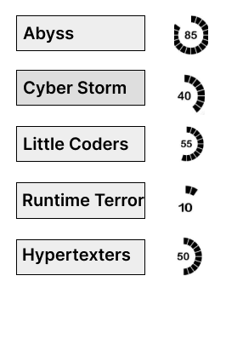

GROUPS PROCESS TRACKER

**WEB WIREFRAMES FOR CLIENT/FACULTY**

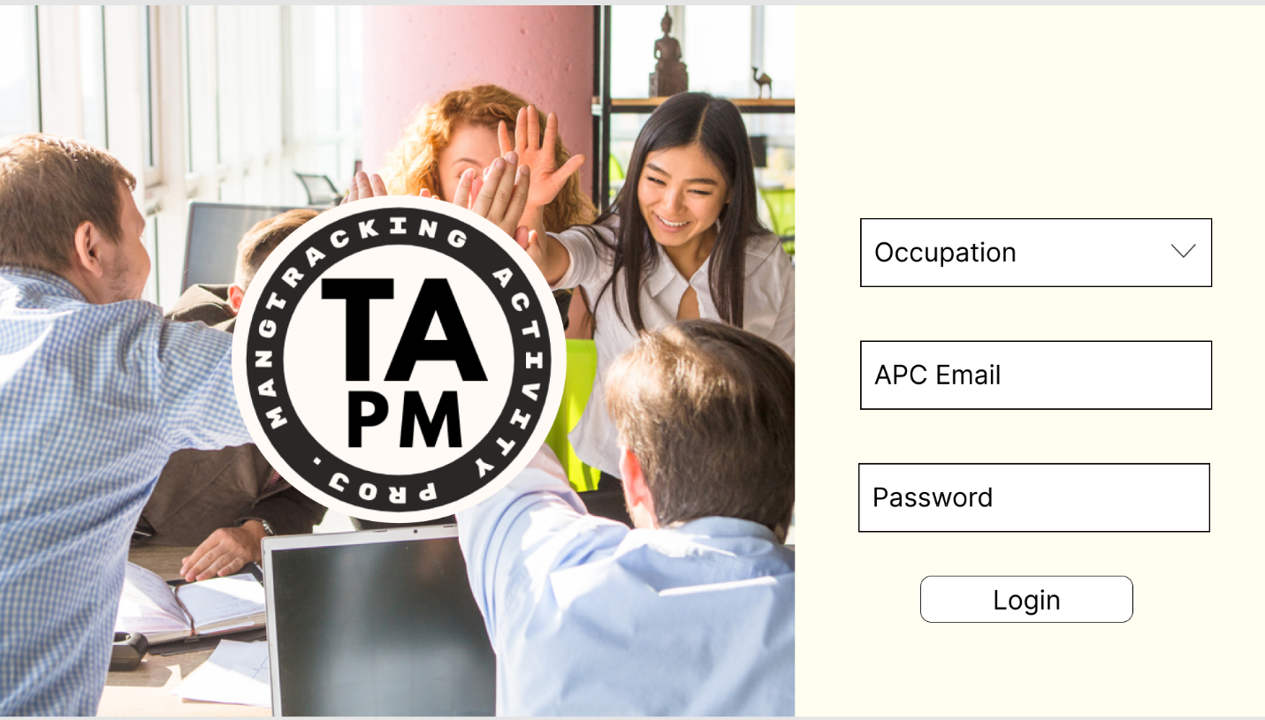

LOG IN PAGE

HOME PAGE

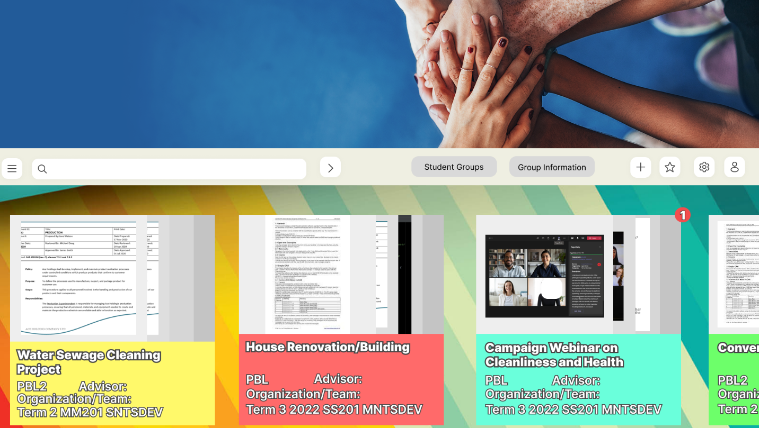

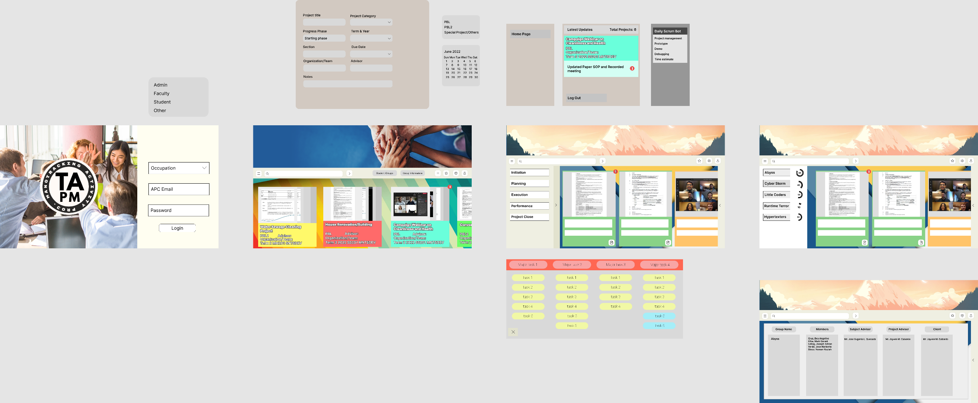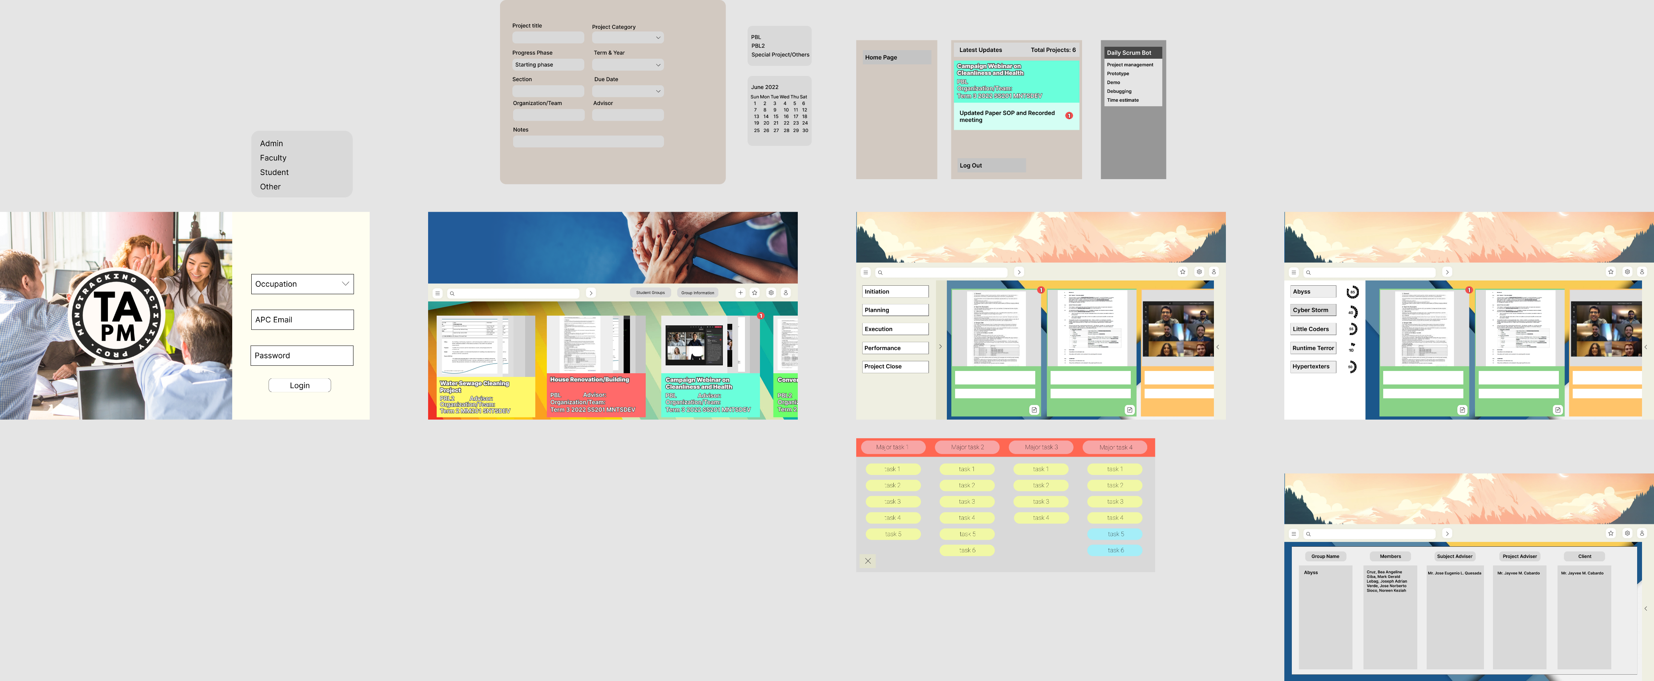

ADDING PROJECTS

FOR PROJECT UPDATES

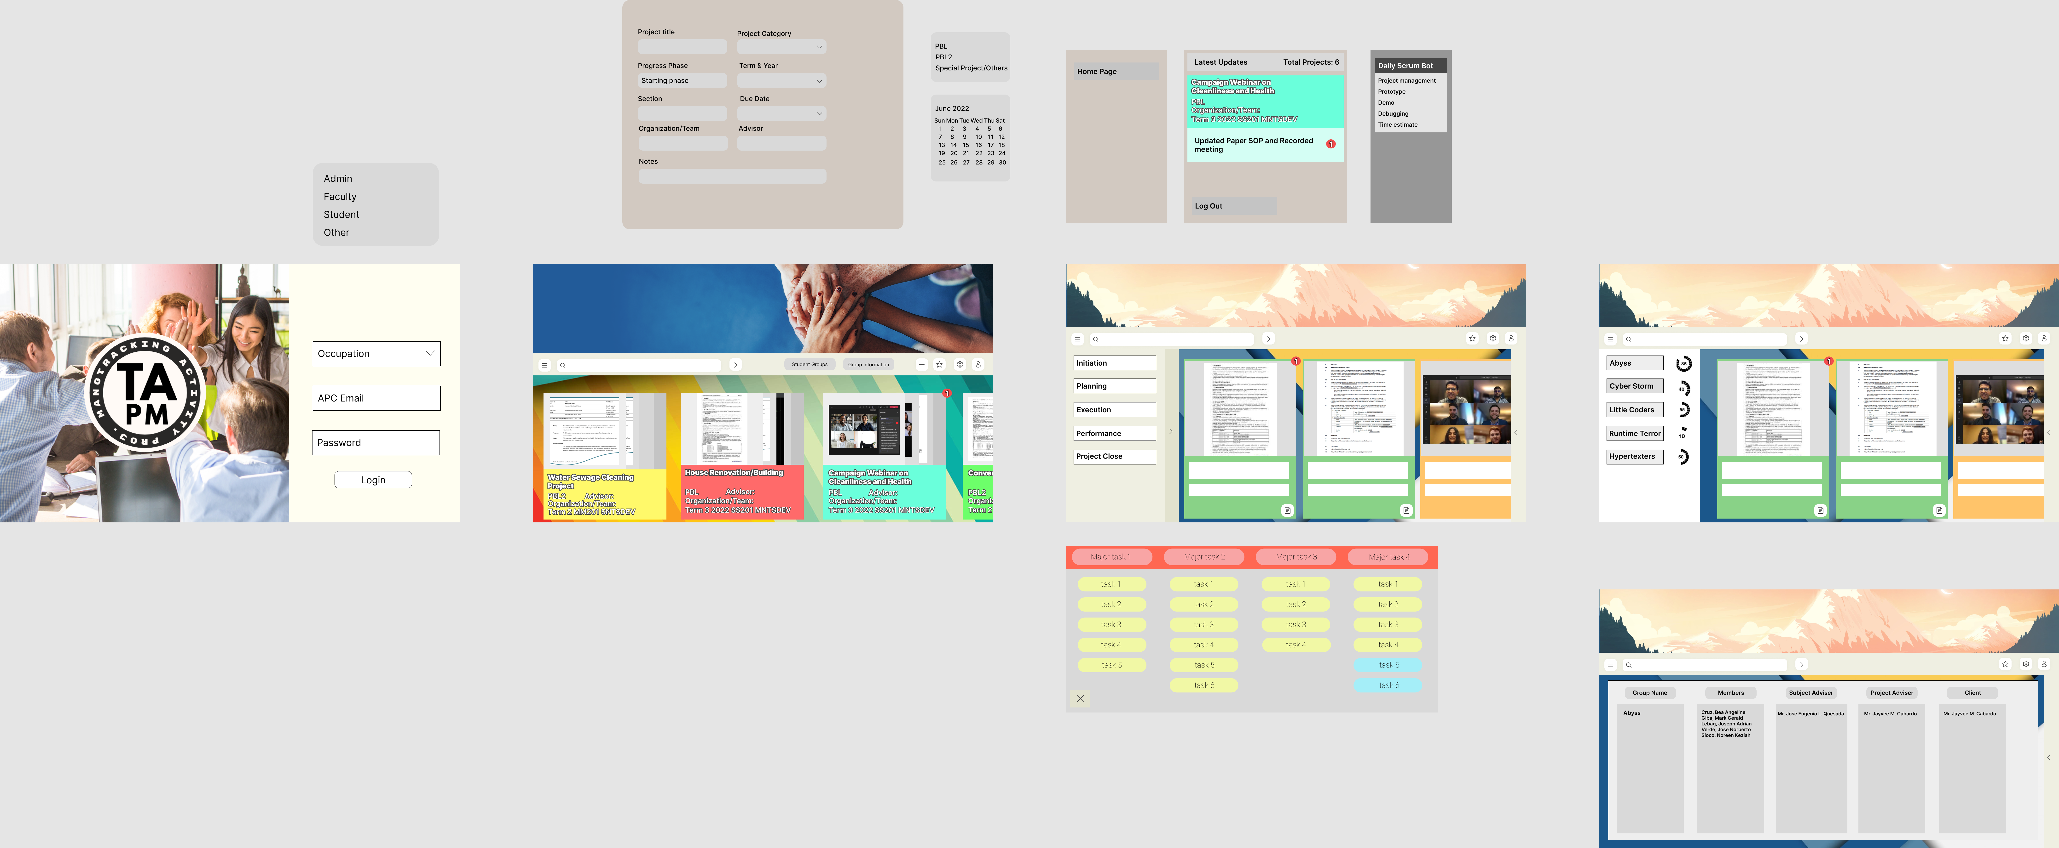

DAILY SCRUM BOT

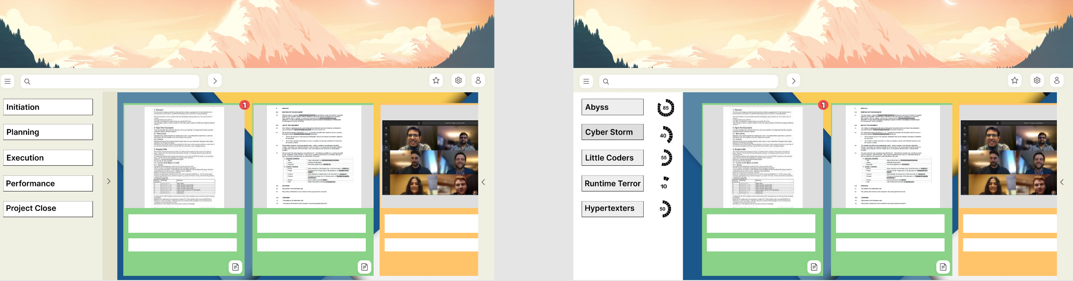

PROJECT’S MONITORING

GUIDE

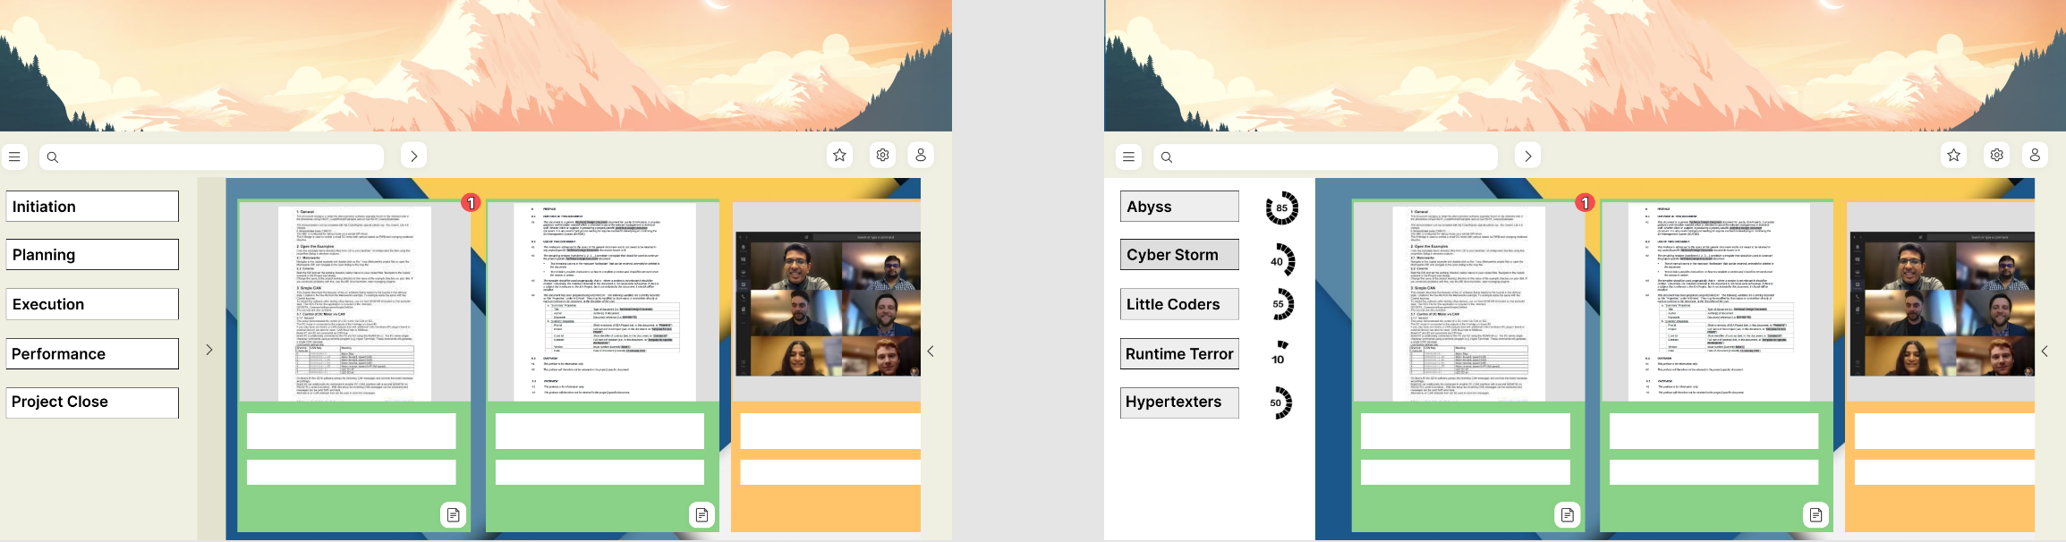

GROUPS PROJECT PROCESS TRACKER



TASK BOARD WITH DATA NUMERIC TRACKER

**WEB WIREFRAMES FOR STUDENTS**



LOG IN PAGE

HOME PAGE





ADDING PROJECTS

FOR PROJECT UPDATES



DAILY SCRUM BOT



GROUPS PROJECT PROCESS TRACKER



**DESIGN THINKING STAGE 5: TEST**

**Before and After Feedbacks of the Prototype**

**Before Landing Page and Log-in/Sign-up**

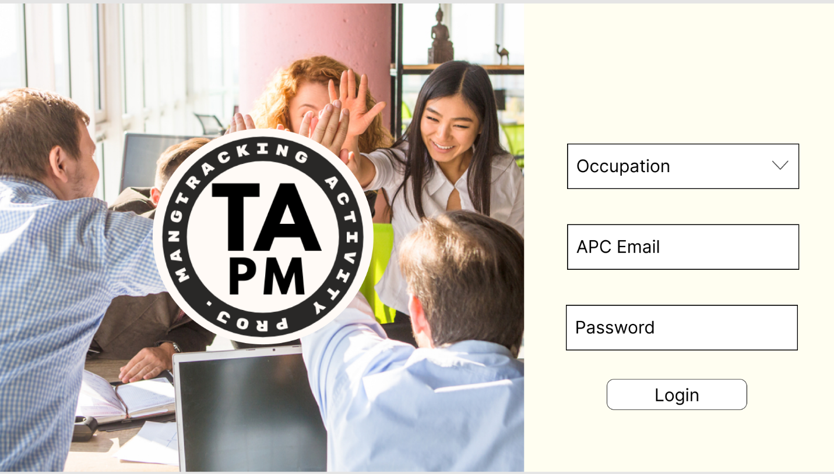**After Landing Page and Log-in/Sign-up**

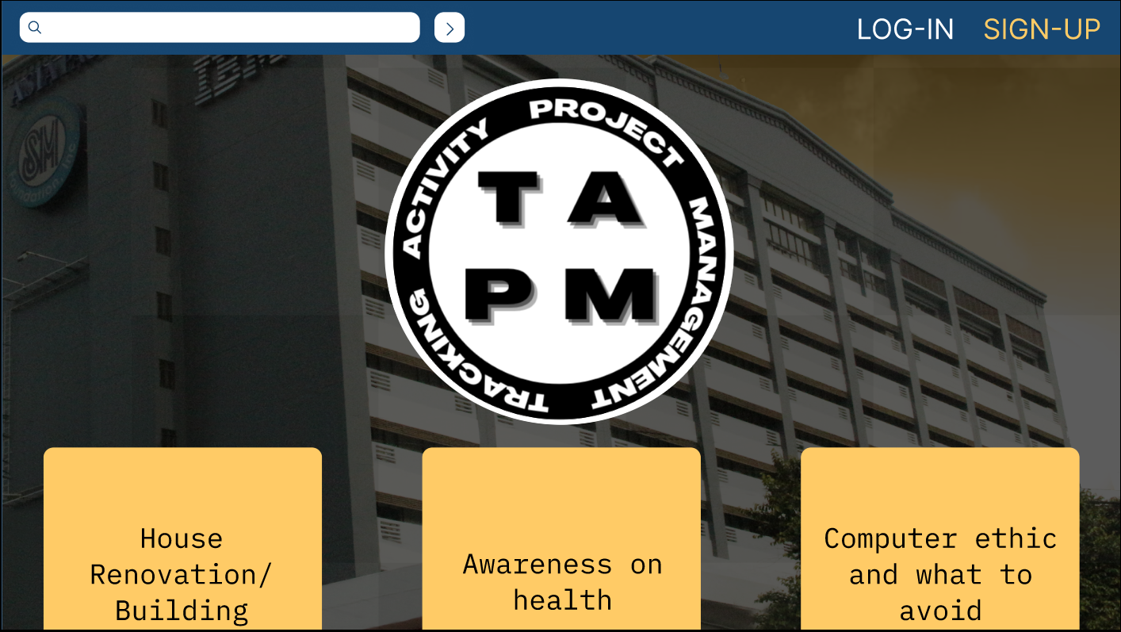

Faculty and Client wanted to change the Log in page as there were recommendation like “*creating an access to certain users and only having the username and password*” by the client or “*using an email to identify the users access to the page*” said by the faculty member. The landing page also seemed lacking and needed a public page where users can view publicly accessible completed projects as recommended to us by our advisor “s*omething similar to the apc view page for the public*.” So, we created the public page along with log-in/sign-up page as an overlay that appears in the side.

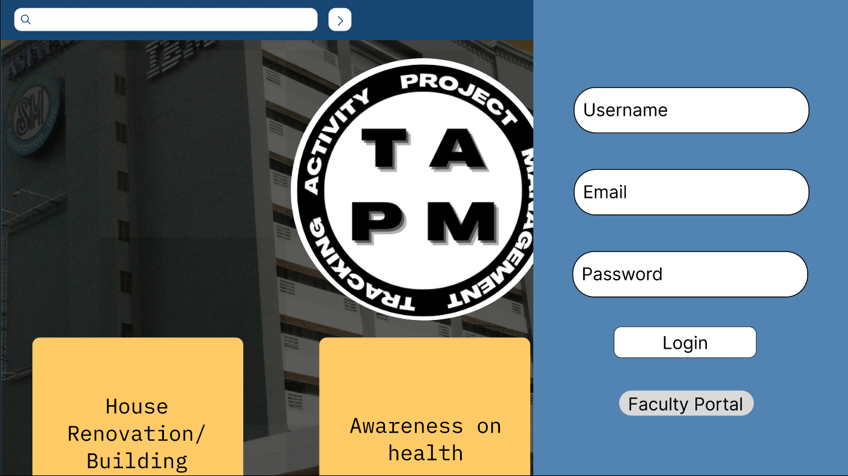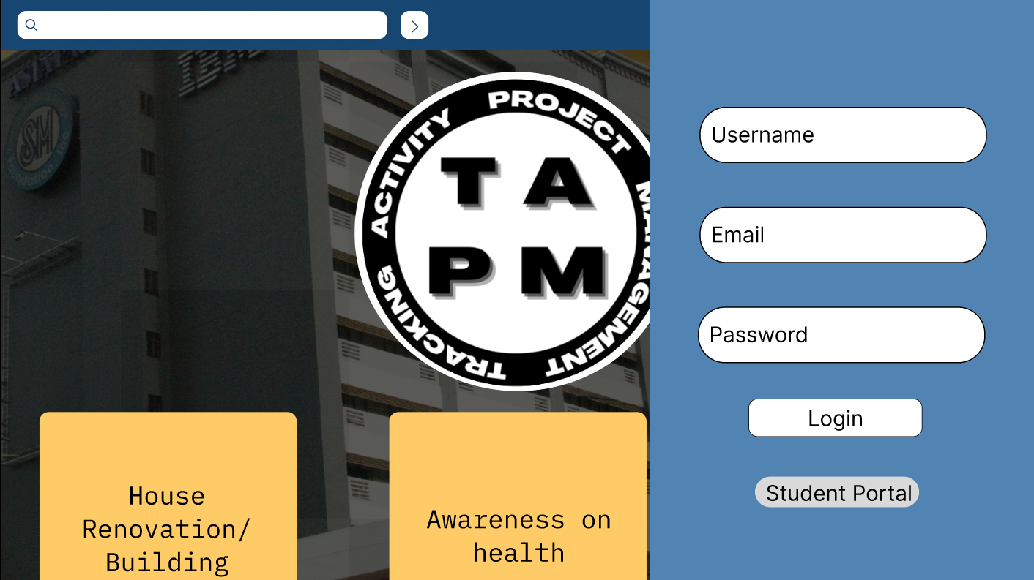

As you can see the log-in/sign-up page shows at the right corner of the screen when clicked and the email will automatically give a different kind of access to either student or faculty members.

**Before Faculty Homepage**

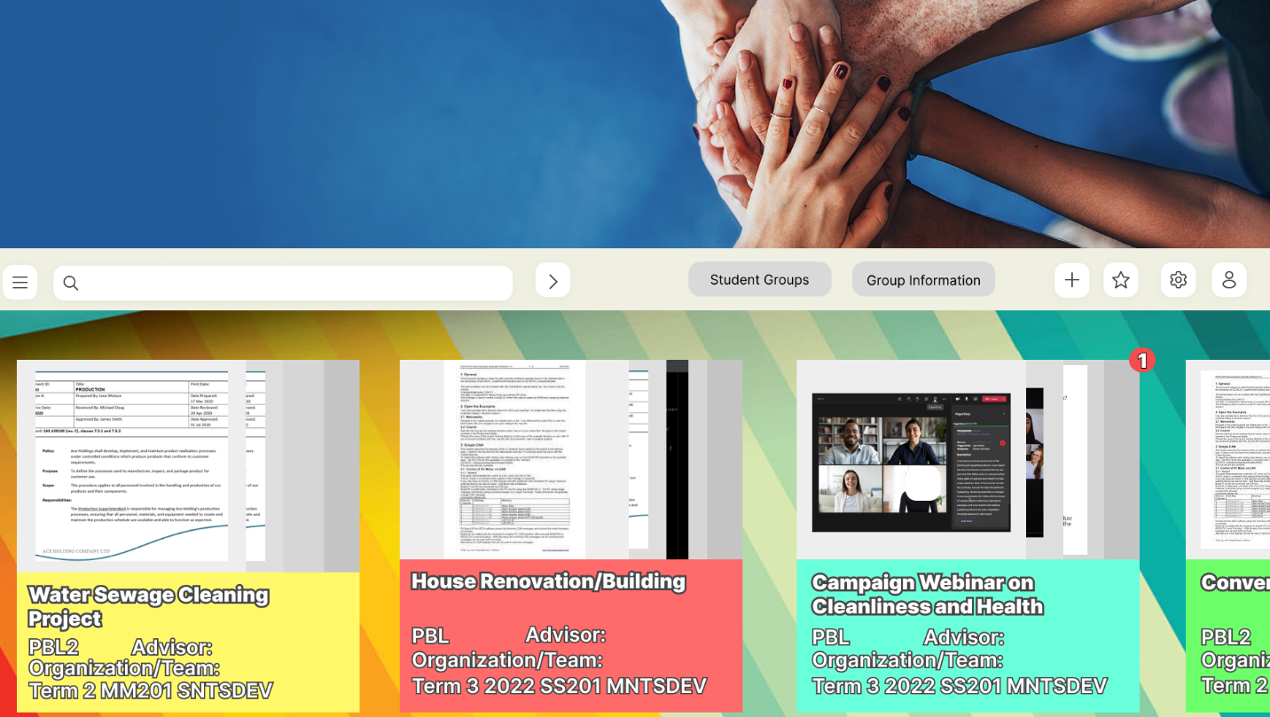

The faculty homepage UI design was not concise as Miss Rosselle said, “*apply UI design practice on our prototype*,” such as the header space and size were too big as said by the faculty consultant and colors did not seem professional and proper.

**After Faculty Homepage**

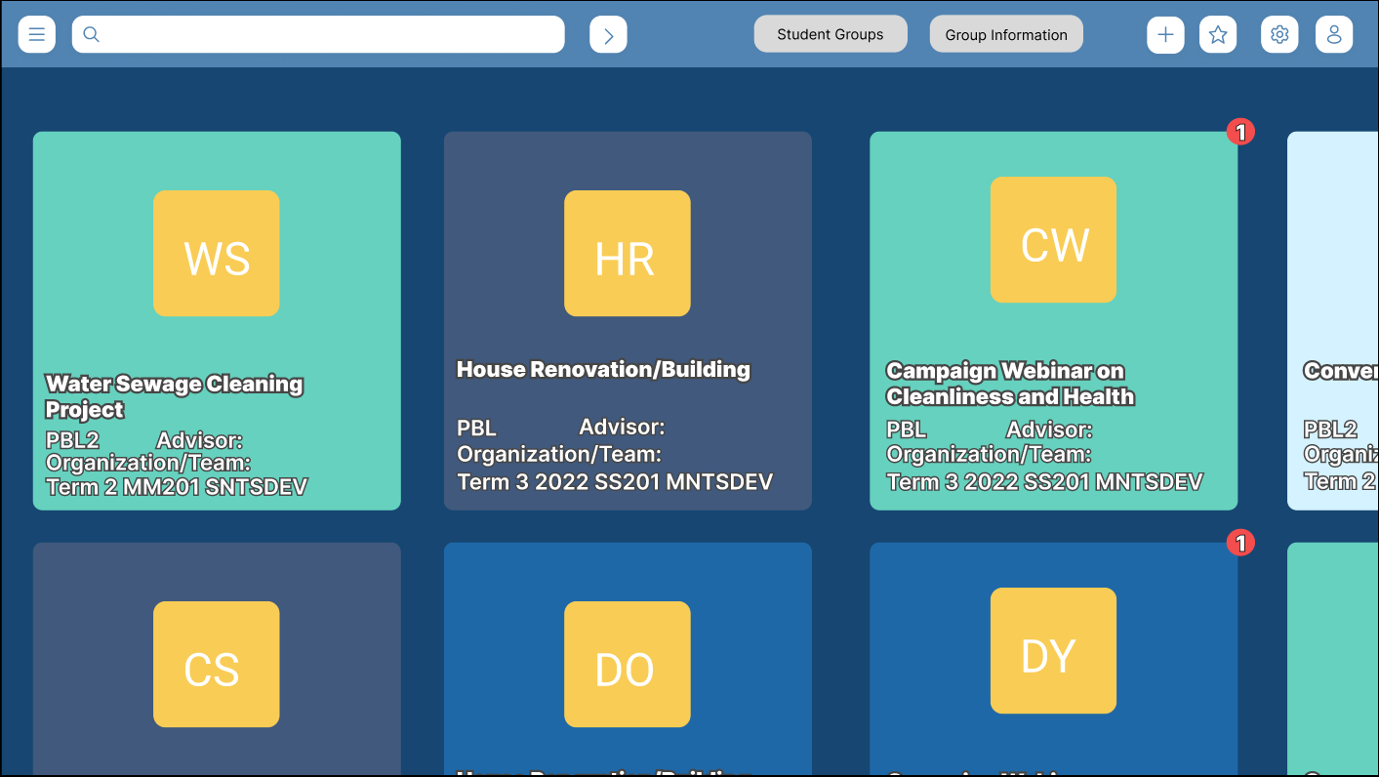

We decided to only match at least three colors on the mock-up and decided on blue, dark blue, light blue and yellow as was said by Miss Rosselle “*change the colors to make it look professional*.” We also completely removed the header to have more room to see the projects underneath and lastly confirmed if the buttons such as the favorites is a necessary function or not from our client.

**Before Student Homepage**



**After Student Homepage**

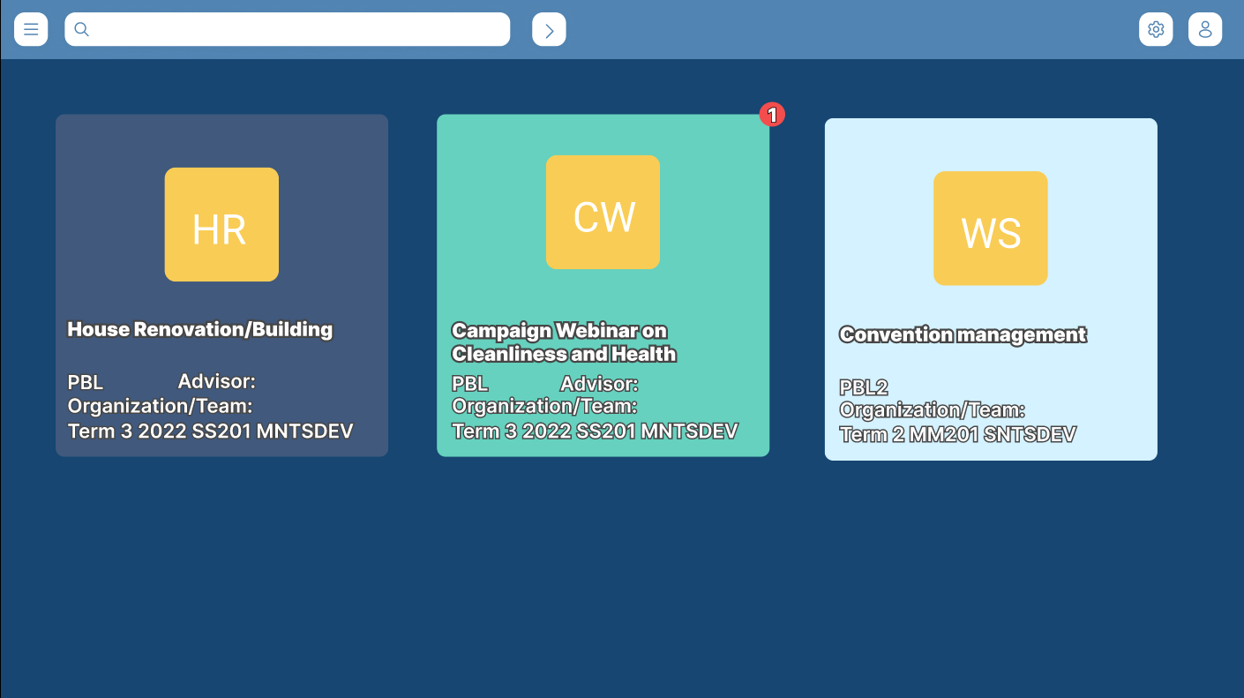

Displayed the perspective of the student based on the comment and removed the number of projects the student handling as said by the Client, “*only have at least two or three the groups handling the projects*” and reduced some of the buttons the student did not need access to such as the group info and student group button. Fixed the UI design, removed the header, and changed the colors according to the theme. Lastly, they did not have access to notifications/updates overlay.

**Before Notification Updates**

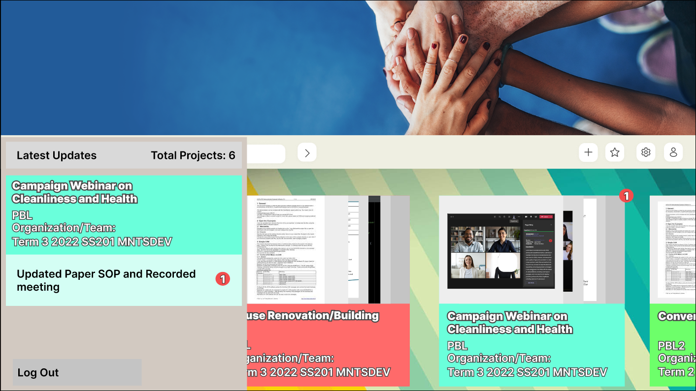

**After Notification Updates**

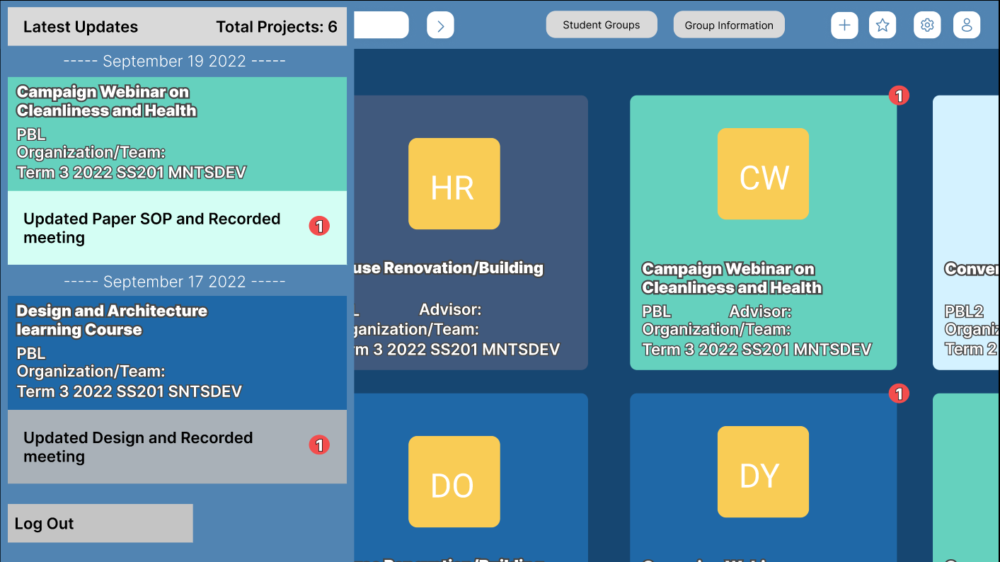

The notification bar was updated based on the feedback from our client and recommended “*adding a date of the notification sent*” to better know which dates these projects were updated.

**Before Student Group Page**

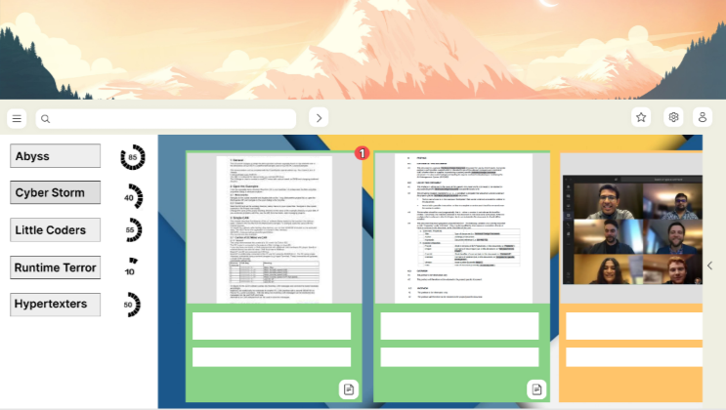

**After Student Group Page**

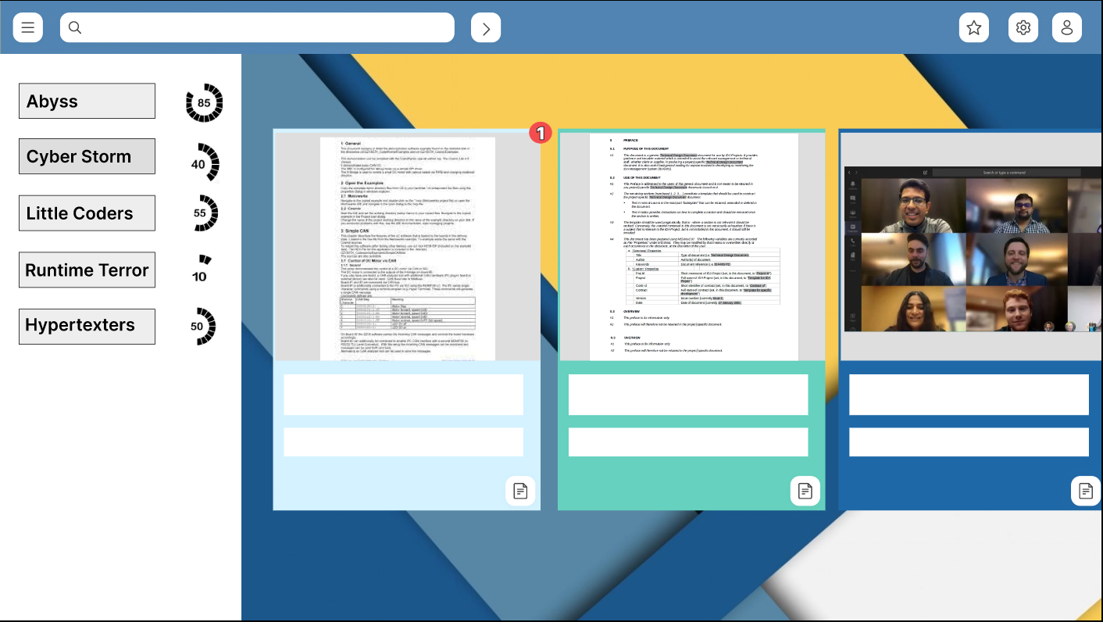

We removed the header on this page and changed the colors to a more professional manner.

**Before Group Information Page**

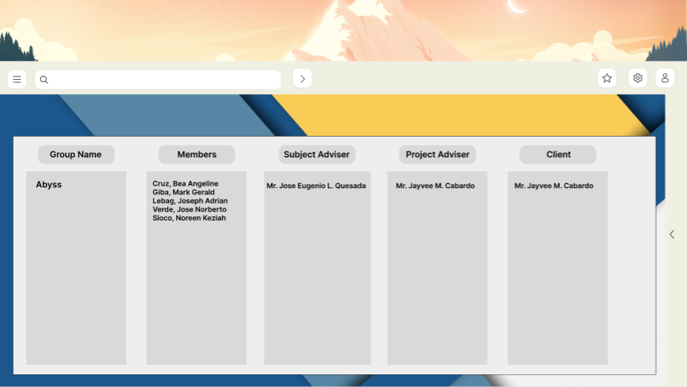

**After Group Information Page**

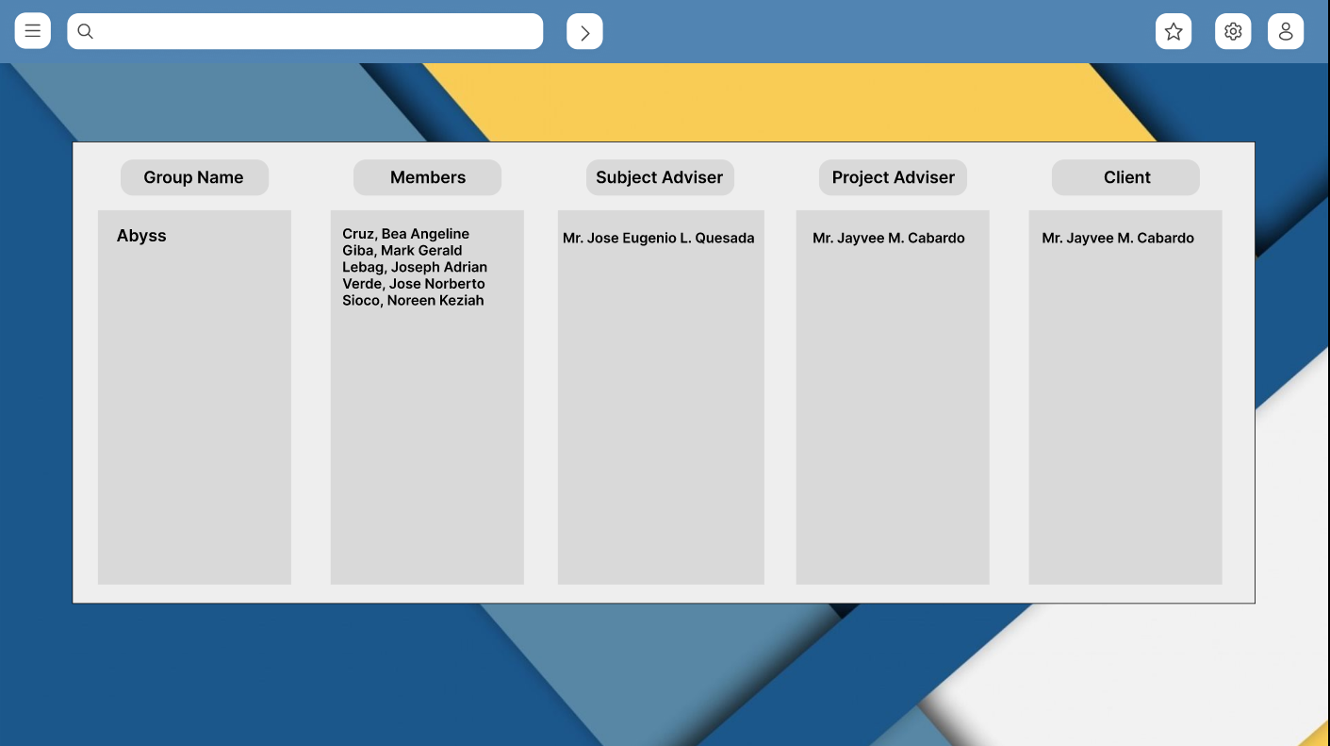

Redesigned UI by removing header and arranging colors according to the chosen theme

**Before Project Team Page**

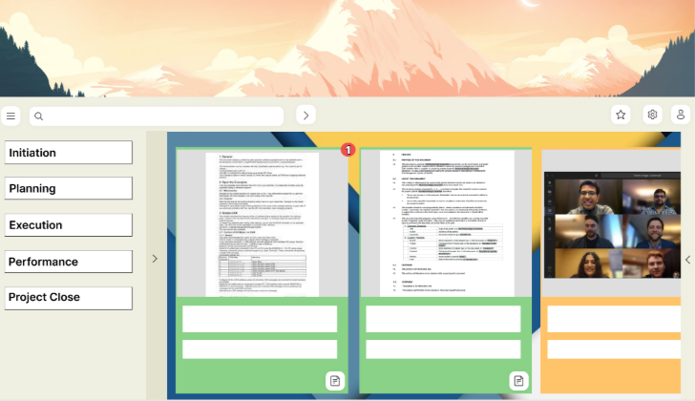

**After Project Team Page**

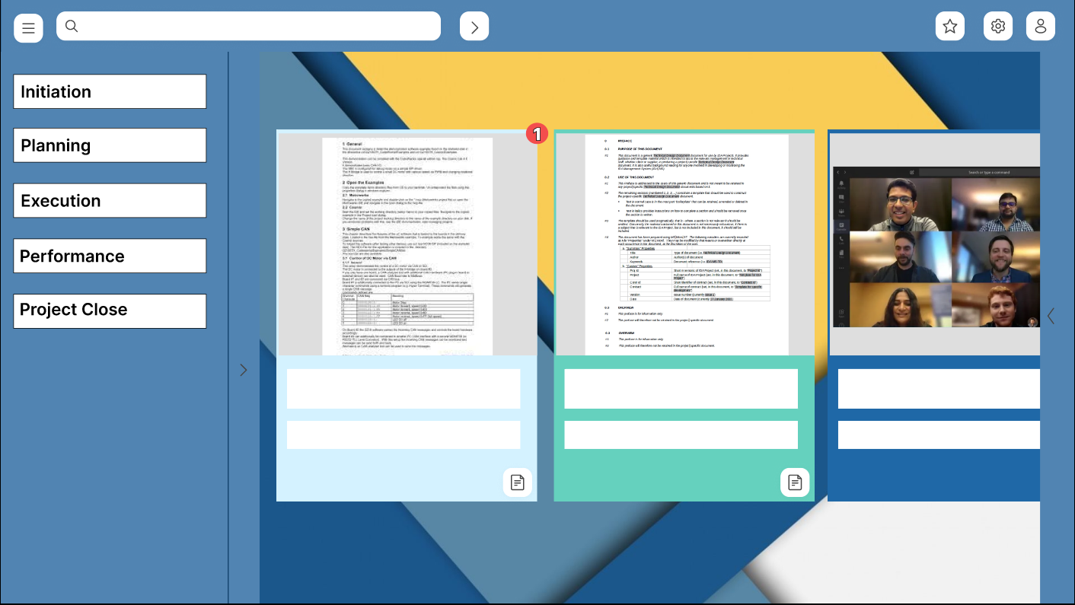

Redesigned UI by removing Header completely and fixing the colors to match the theme

We also added what happens when the comment/ feedback button is clicked, and an overlay will appear in the screen.

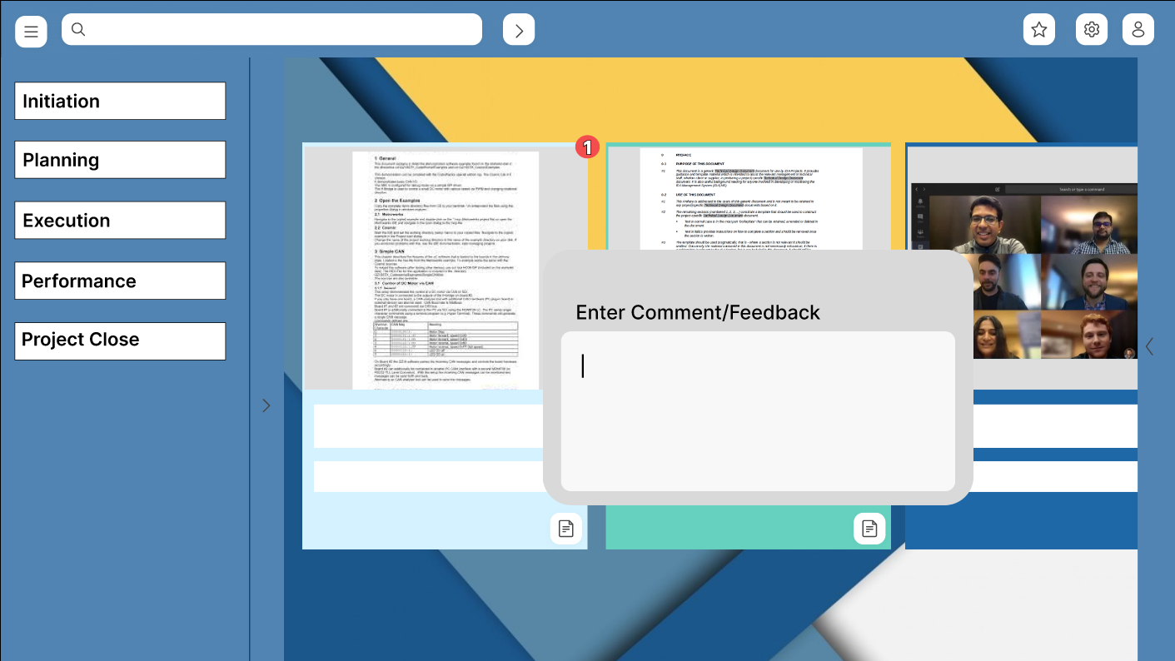

**Before Student Task board**

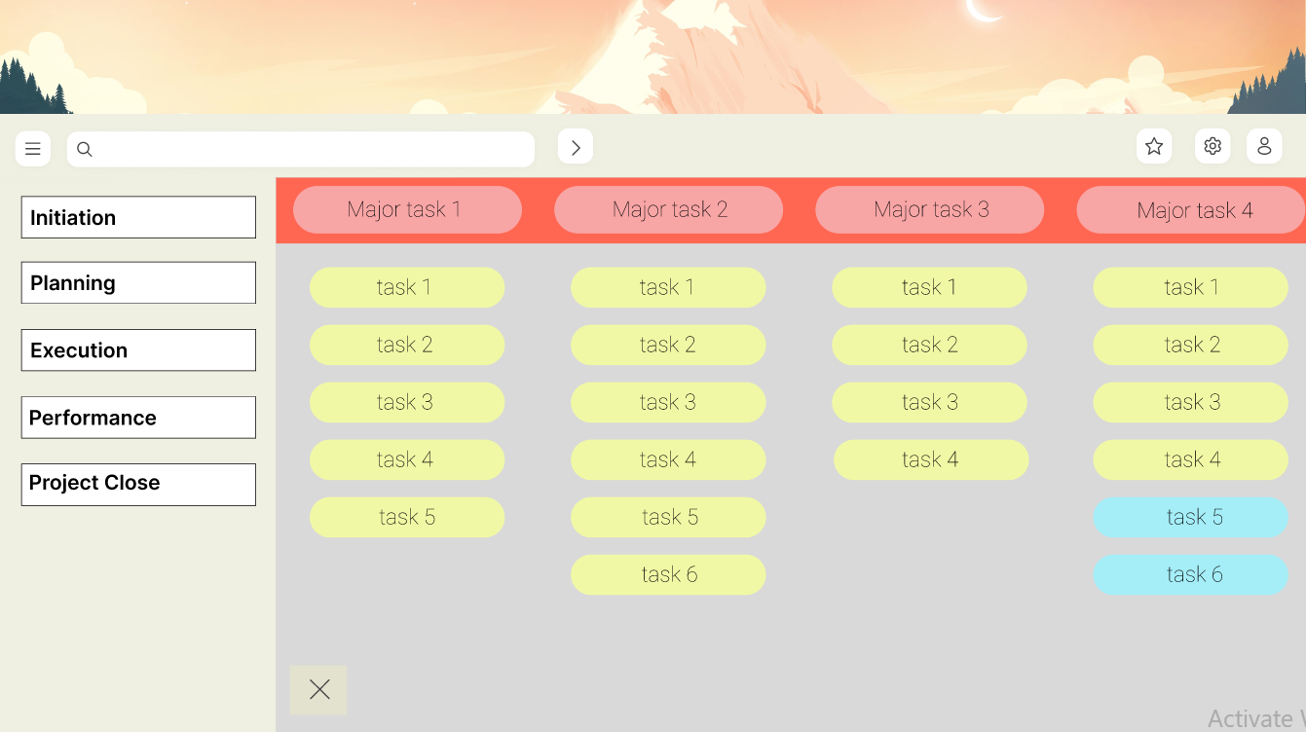

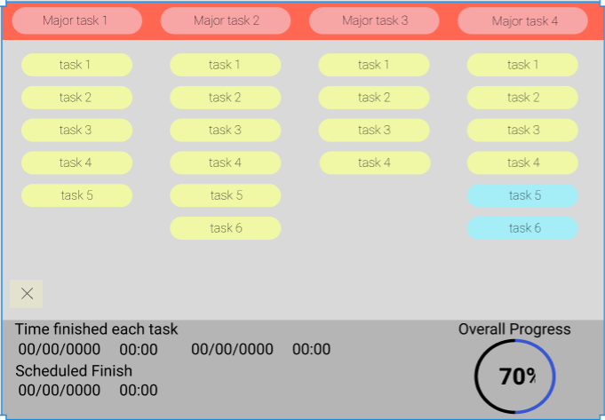

Scrollable horizontally and vertically needed to be adjusted and UI design such as header must be fixed

**After Student Task board**

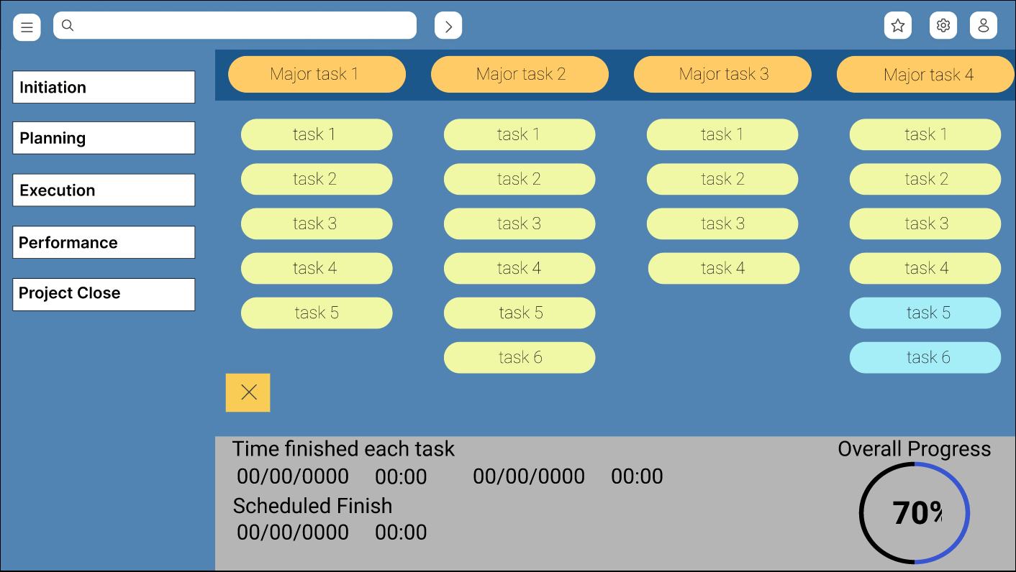

Student Task Board was adjusted to fit the rectangle and can only now conveniently scroll vertically and not horizontally, and color matches the theme.

CLIENT DEMO DOCUMENTATION

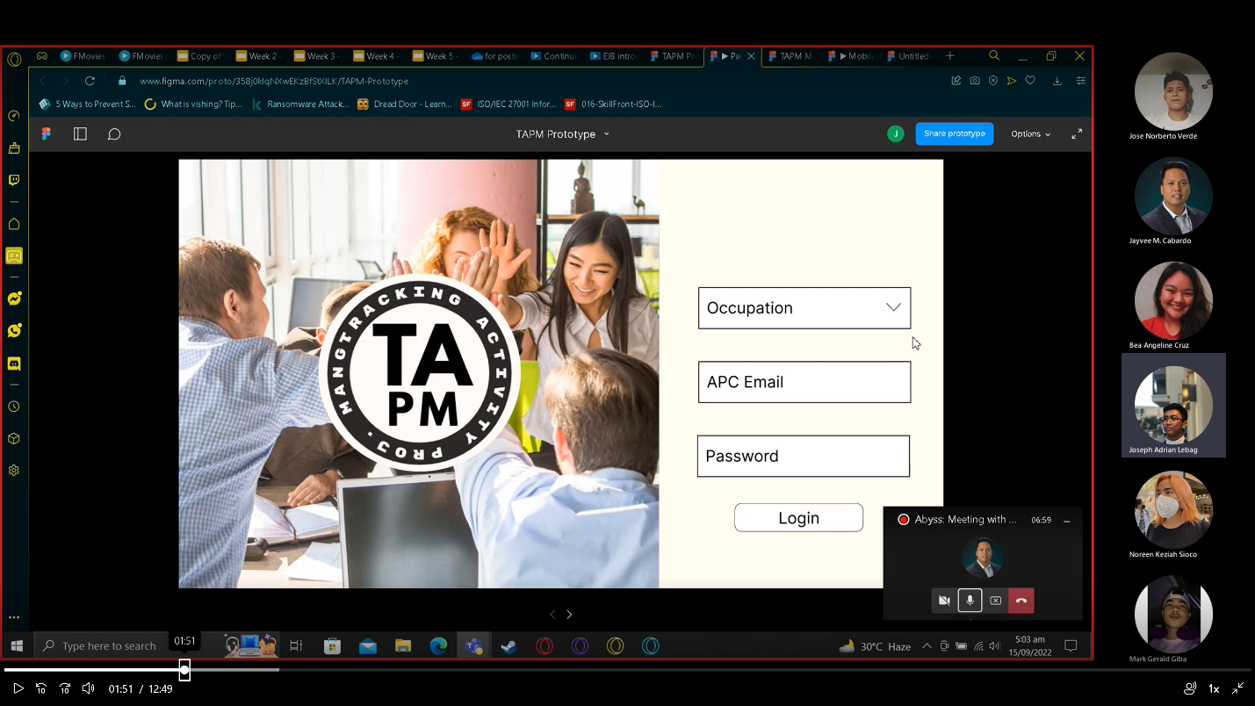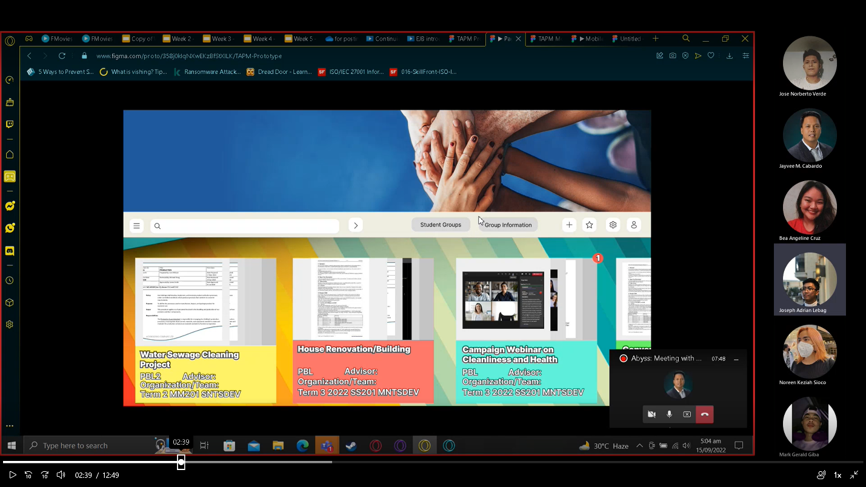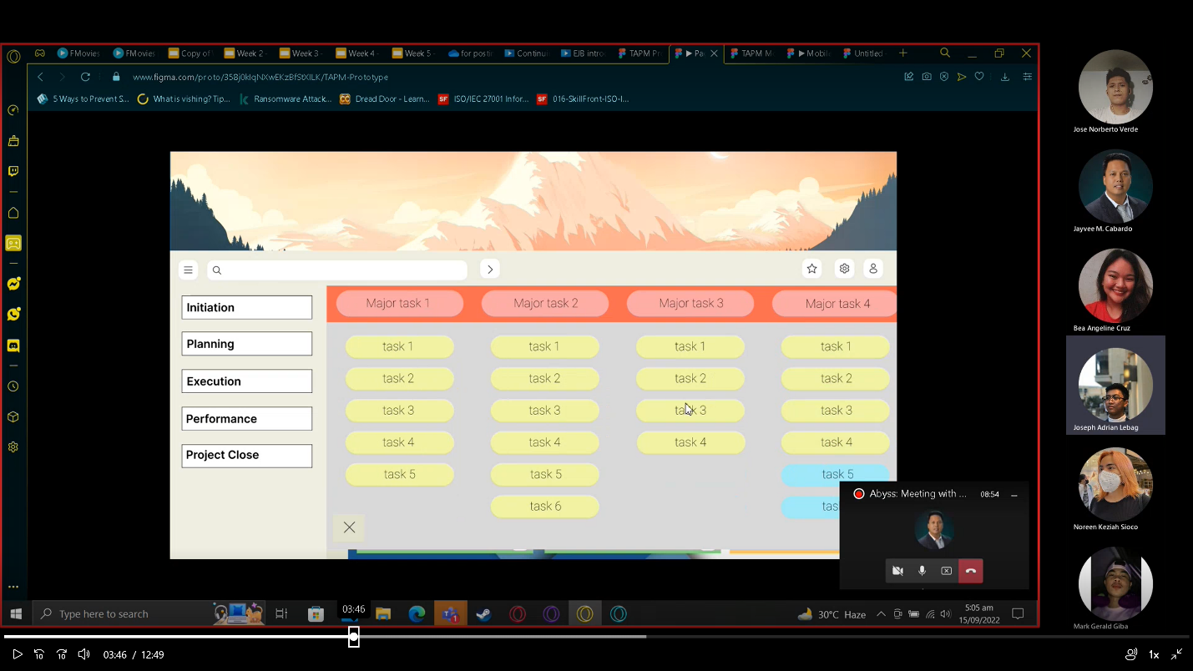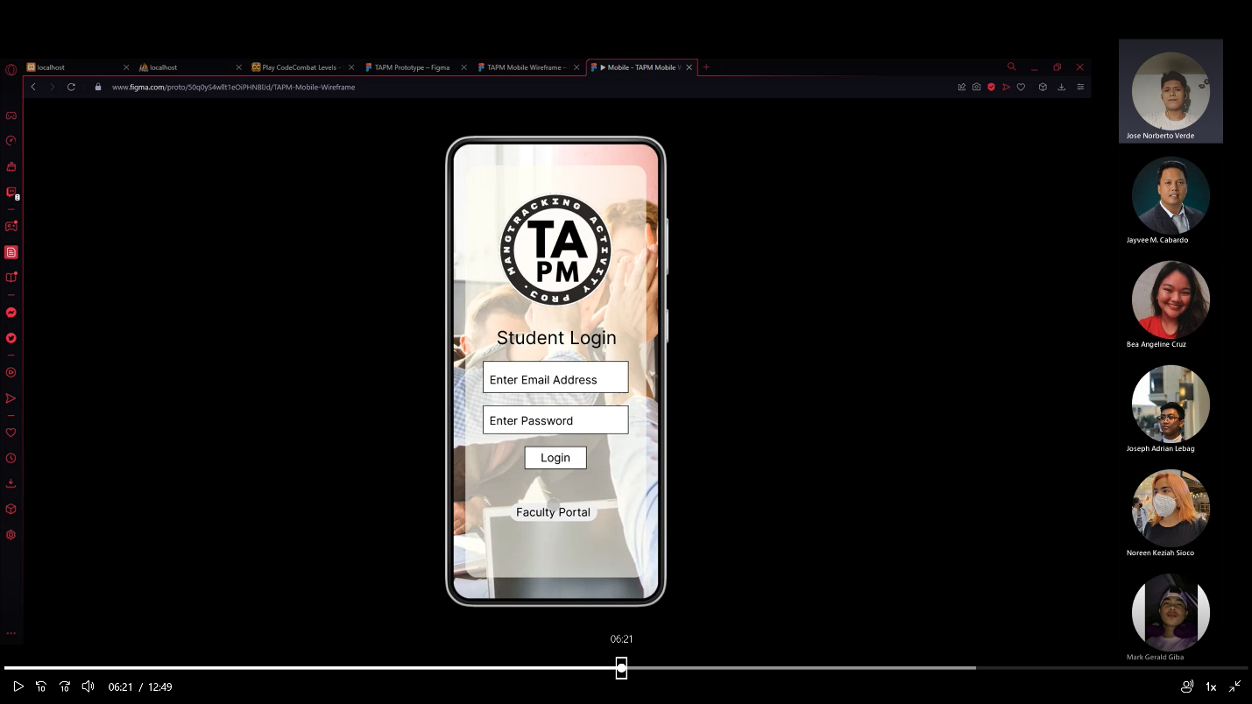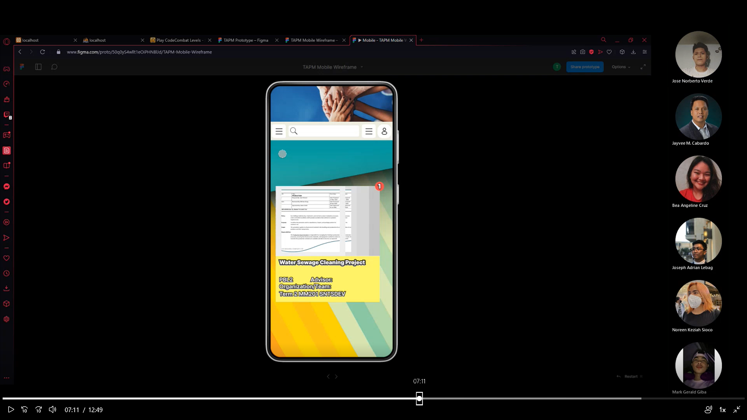

FACULTY DEMO DOCUMENTATION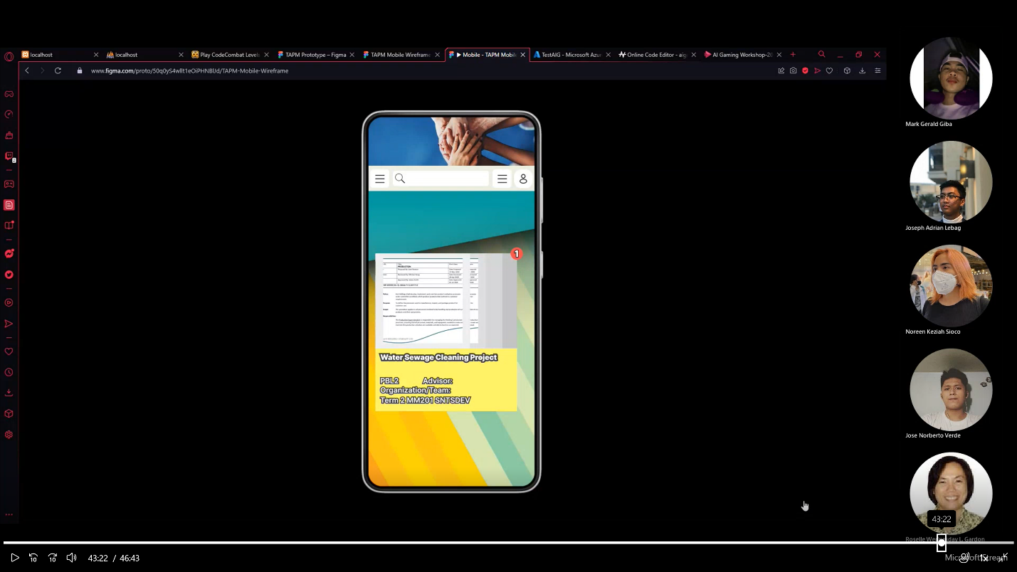

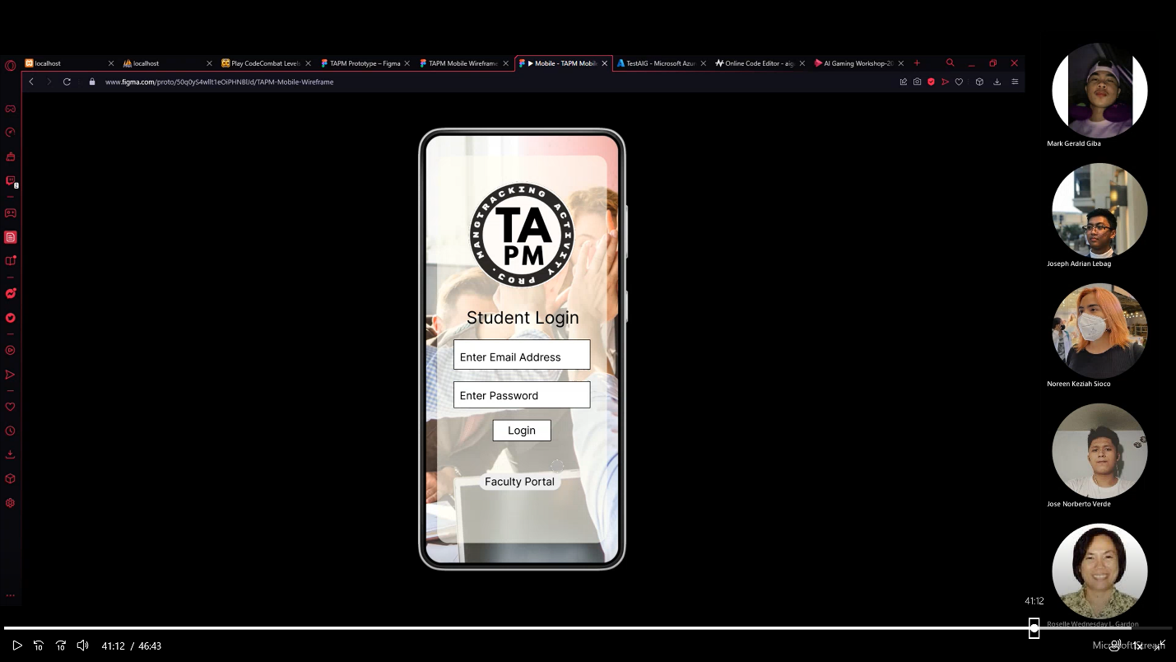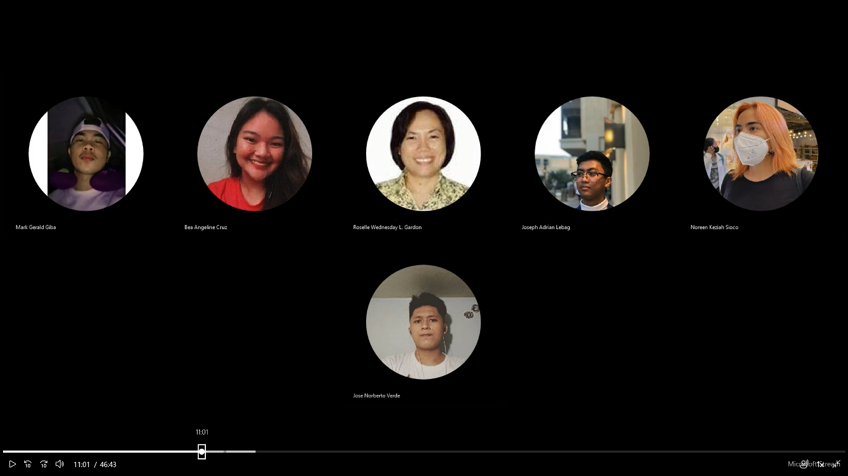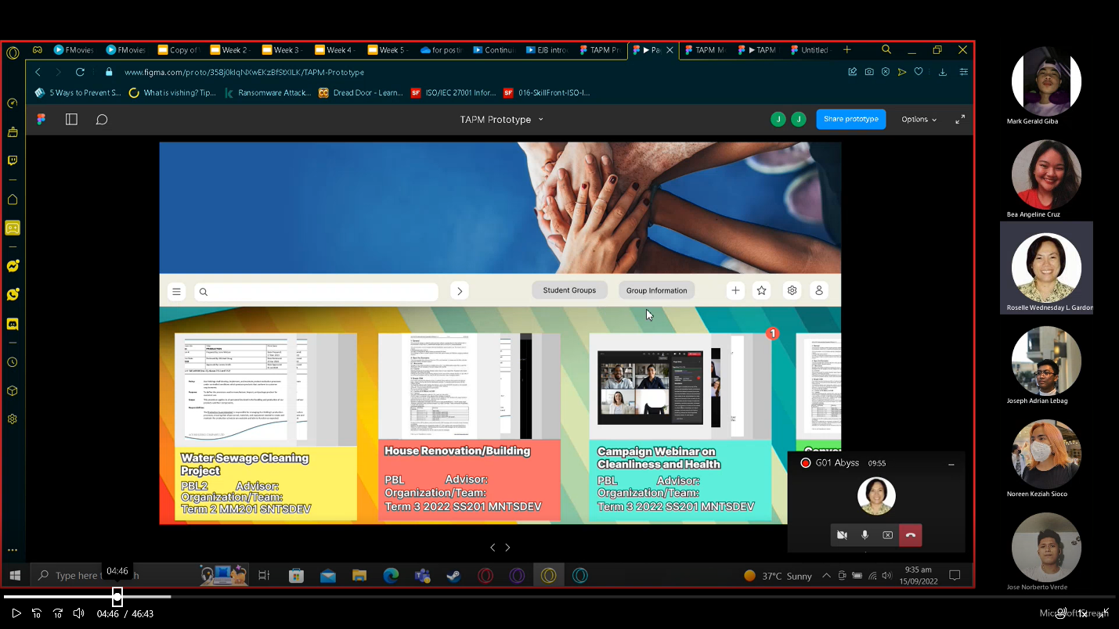

STUDENT DEMO DOCUMENTATION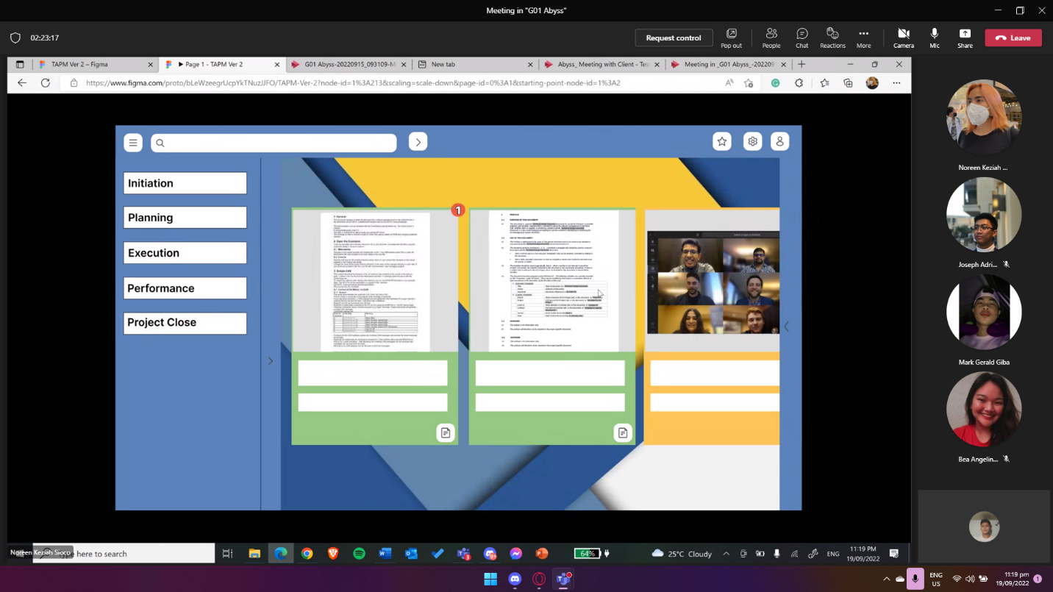

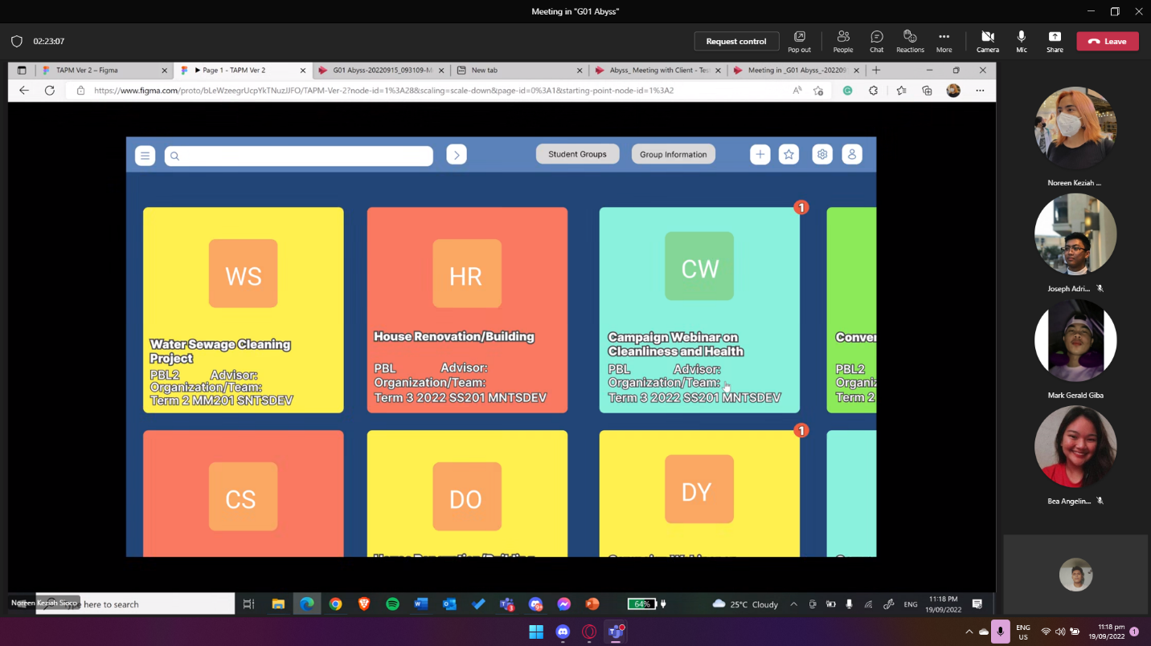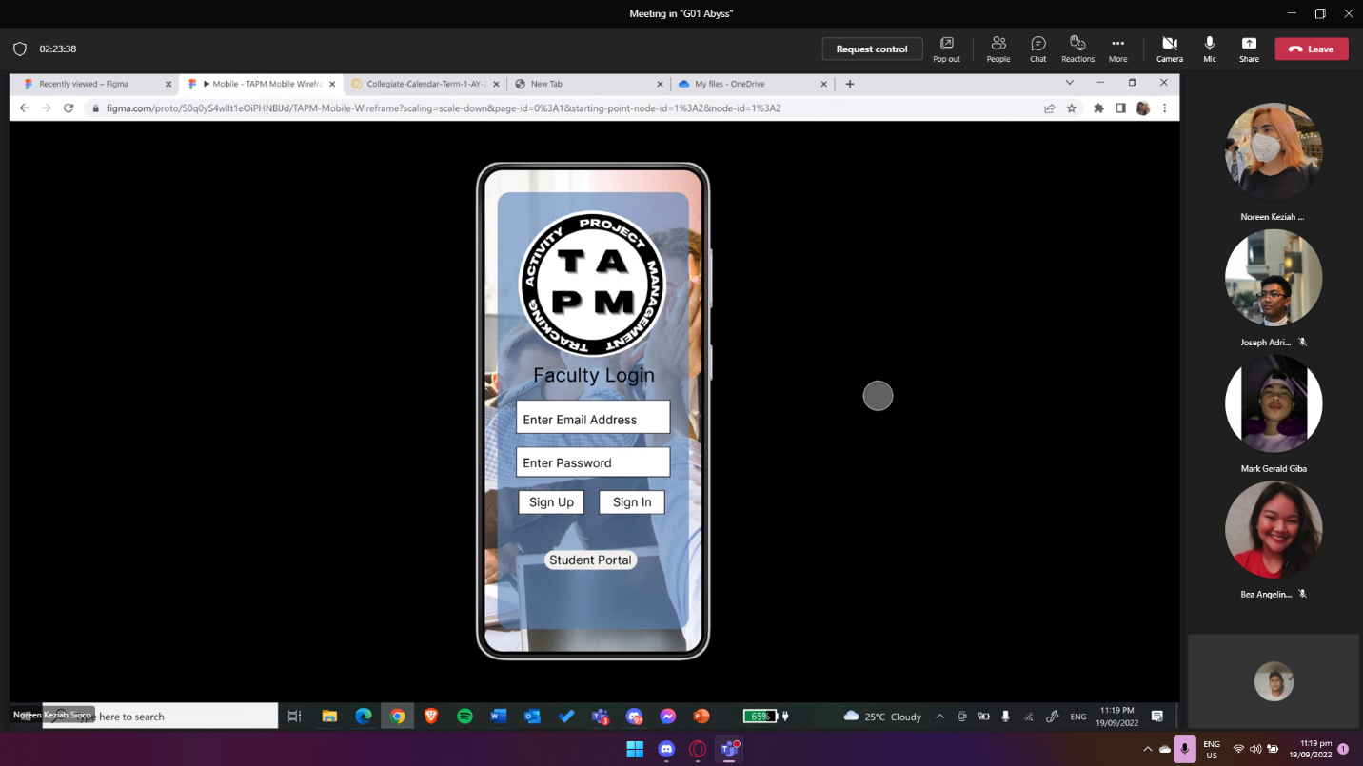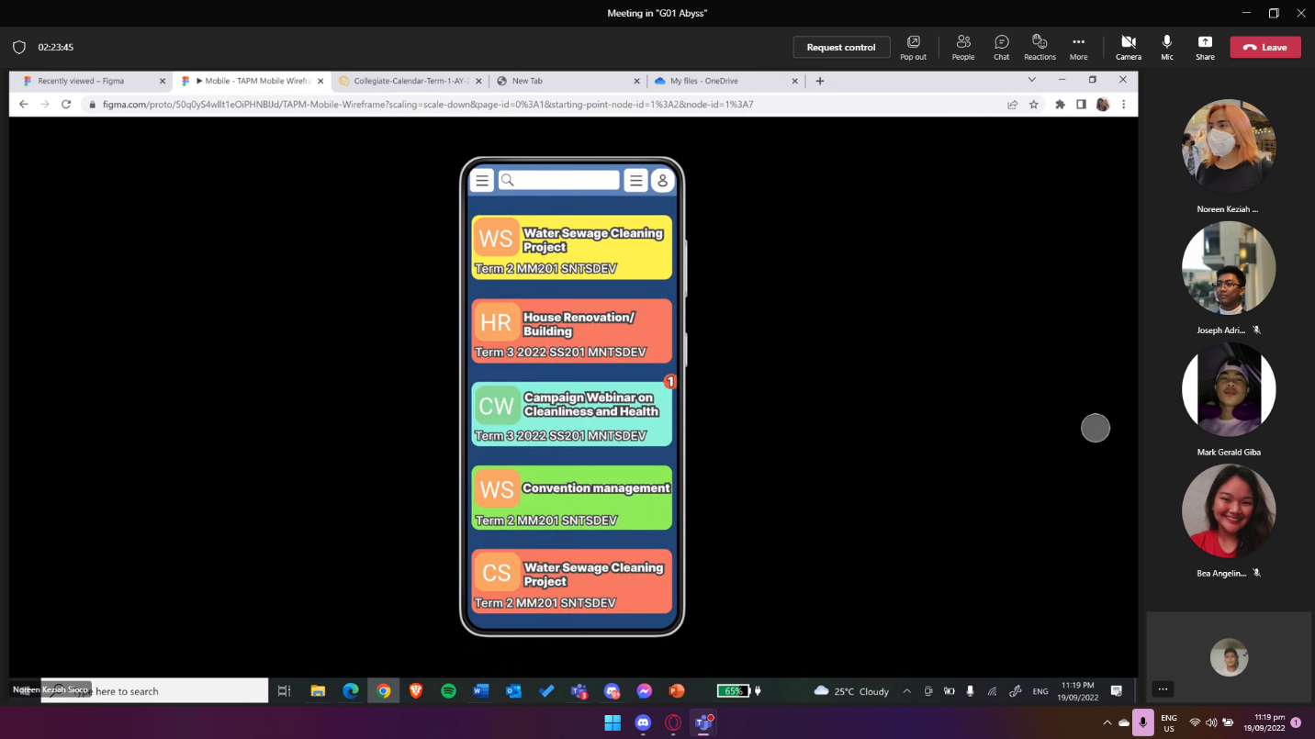

STAGE 5 FEEDBACKS

|  |  |  |
| --- | --- | --- |
| **CLIENT** | **FACULTY** | **STUDENT** |
| * User friendly * Needs changes in the log-in page. * Suggested to be seen by the public. | * Create a public page. * Suggest using APC email. * Remove unnecessary details in the user interface. * Give specific meaning to the color-coded features and adjust the sequence of the projects. * Fix homepage. * Ask the client if the favorite button is necessary. * Details on the task features should be simple as much as possible. * Fix logos make it readable. | * Helped me to be more productive because of the feature numeric data tracker. * Beginner friendly and can easily use the functions of the project proposed. * The UI design needs to be improved. * The details in the user profile are not clear. |

PRODUCT BACKLOG

|  |  |  |  |  |
| --- | --- | --- | --- | --- |
| **Product Backlog** | | | | |
| **ID** | **As a…** | **I want to be**  **able to…** | **So that…** | **Priority** |
| 1 | Project Development Officer | Create a new project that can be easily accessed by the developers assigned. | The developers can easily see the project and communicate with the Project Development Officer. | Must |
| 2 | Project Development Officer | Have a better monitoring and tracking tool to be more hands-on to the projects that I've assigned to the developers. | The developers can be updated on time on with the needed changes for their assigned projects. | Must |
| 3 | Project Development Officer | Add comments to improve the project that is assigned to the given developers. | The developers can take note of the details that needed to be added to the project. | Must |
| 4 | Project Development Officer | Assist in developing the project with the developers and their consultant. | The developers can avoid possible mistakes and misunderstanding with their project. | Must |
| 6 | Student | Cooperation with the project development director, faculty, and client. | They can assist the developers with their project in progress. | Must |
| 7 | Student | Update the status about the progress of the research project | If there are some revisions needed about the project, they can revise it immediately. | Must |
| 8 | Student | View the project task and instructions given by the Project Development Officer and Faculty. | Mistakes in doing the project can be avoided. | Must |
| 9 | Student | Upload files and updates about the research project | The project director can view the project. | Must |
| 10 | Faculty | Participate in design development and construction development planning stage with the developers. | The developers can have a better idea on the project they are developing. | Must |
| 11 | Faculty | Guide developers on the process of creating their projects such as creation of project proposal and project features. | The developers can have a better outcome of the project being developed. | Must |
|  |  |  |  |  |
| 12 | Faculty | Collaborate and monitor the updates of the developers to check if they are on the right track in creating their projects. | Mistakes can be avoided. | Must |
|  |  |  |  |  |
| 13 | Client’s Partner | Participate in the development process of the project. | Client’s vision can be followed. | Must |
|  |  |  |  |  |
| 14 | Client's Partner | View the project that are being processed. | The product delivery that client needs can be provided. | Must |
|  |  |  |  |  |

**GROUP ABYSS**

**LEADER**:

NOREEN KEZIAH SIOCO

**MEMBERS**

BEA ANGELINE CRUZ

MARK GERALD GIBA

JOSEPH ADRIAN LEBAG

JOSE NORBERTO VERDE

**INDIVIDUAL GROUP CONTRIBUTIONS**

**NOREEN KEZIAH SIOCO**

Stage 1- Interviewed the faculty for the 5 Why’s.

Stage 2- Contributed to Clustering problems areas and how/might/we imagine question 1.

Stage 3- Crazy 8’s first question and solutions.

Stage 4- Project story board and designed the low fidelity wireframe for the prototype.

Stage 5- Did the testing of the prototype for the faculty. Contributed to the product backlog.

**BEA ANGELINE CRUZ**

Stage 1- Listed the client, faculty, and student’s interview responses.

Stage 2- Contributed to Clustering problems areas and how/might/we imagine question 2.

Stage 3- Crazy 8’s second question and solutions.

Stage 4- Added details for the low fidelity wireframes.

Stage 5- In charge of the feedbacks given by the client, faculty, and student.

**MARK GERALD GIBA**

Stage 1- Interview the student for the 5 Why’s.

Stage 2- Contributed to Clustering problems areas and how/might/we imagine question 3.

Stage 3- Crazy 8’s third question and solutions.

Stage 4- In charge of listing the information needed by the client, faculty, and student for the prototype.

Stage 5- In charge of testing the prototype for the student. Contributed in the product backlog.

**JOSEPH ADRIAN LEBAG**

Stage 1- Interviewed the client for the 5 Why’s.

Stage 2- Contributed to Clustering problems areas and how/might/we imagine question 4.

Stage 3- Crazy 8’s fourth question and solutions.

Stage 4- Designed the web version of the prototype.

Stage 5- In charge of testing the prototype for the client. Contributed in the before and after of the prototype.

**JOSE NORBERTO VERDE**

Stage 1- Assigned to do the final word document for stage 1.

Stage 2- Contributed to Clustering problems areas and how/might/we imagine question 5.

Stage 3- Crazy 8’s fifth question and solutions.

Stage 4- Design the mobile version of the prototype.

Stage 5- Contributed to the product backlog. Contributed in the before and after of the prototype.